FINANCIAL RESULTS FOR
THE FIRST QUARTER OF 2014

Contact:

INA-Industrija nafte, d.d.
Corporate Communications Sector
Avenija Veceslava Holjevca 10, Zagreb

Public Relations Department

E-mail: PR@ina.hr
Or visit Press Centre at www.ina.hr

INA published financial results for the first quarter of 2014

- Capital investments increased by 72 per cent, to more than HRK 280 million
- Oil production increased on existing fields in Croatia
- Lower gearing, decreasing from 30.6% to 26.2%
- Operating cash flow still strong
- Diesel share in sales increased

Zagreb, 30 April 2014 – INA Group’s EBITDA for Q1 2014 amounted to HRK 831 million. At the same time net profit amounted to HRK 241 million. Operating cash flow remains strong, at HRK 452 million in Q1 2014 while the Group’s financial position improved further as gearing level decreased to 26.2% in this quarter from 30.6% a year ago. Net debt amounted to HRK 4,687 million, 31% lower compared to the end of Q1 2013.

Capital expenditures in Q1 2014 increased significantly by 72% compared to Q1 2013, amounting to HRK 280 million. The predominant part, HRK 203 million, was invested in the Upstream segment in Croatia.
In Upstream, INA managed for the first time in the last ten years to increase crude oil production from existing fields in Croatia compared to the same quarter in the previous year by 3%. This is the result of an intensive well workover program launched late last year. This way the natural production decline trend of these fields, which INA has successfully mitigated already in the past 3-4 years, is temporarily reversed. Our similar efforts were also visible in onshore gas production, limiting the natural decline to a very low 1% against Q1 2013, while offshore gas production seems to be stabilizing.

Refinery operations are still burdened by the unfavourable external environment, with 27% and 32% lower average crack spread quarter on quarter and year on year, respectively. Despite that, sales structure improved with higher diesel share. INA maintained its strong retail and wholesale position in Croatia and continued to increase in Bosnia and Herzegovina.

The decrease of sales revenues by 22% compared to Q1 2013 is largely due to accommodating our natural gas sales to close to the level of our domestic production, with decreased import. Also, refinery utilization and refined product sales were adapted to market circumstances (i.e. less available profitable export sales opportunities).

Statement by Mr Zoltán Áldott, the president of the Management Board:

„As a result of our consolidation program that we implemented in INA over the last 4 years we managed to solidify INA’s financial position. Now, keeping the required financial prudence, our efforts have been focused on further enhancing our market position in a value-creating way and on implementing our growth projects, primarily in our upstream segment.

In upstream, due to the management’s concentrated attention to compensate the natural production decline of our legacy assets, we managed to increase oil production from our existing domestic fields, an achievement unprecedented in the last decade.
In downstream we adjusted our sales pattern even more to market needs by increasing value-added diesel sales and decreasing negative margin heavy residue sales.

We have created a strong platform for investments growth to set our company on a sustainable growth path. Although recent regulatory changes shall limit the dynamism and the availabel funds to fuel this growth but I can say with confidence that INA is on a good track.”

Operative results overview

- INA Group’s revenues reached HRK 5.5 billion
- EBITDA was HRK 831 million
- Operating profit amounted to HRK 390 million
- Net profit amounted to HRK 241 million
- Capital expenditures reached HRK 280 million
- Decreased financing costs and improved gearing levels, which declined from 30.6% in the same period of 2013 to 26.2% as of 31 March 2014

Capital expenditures
(HRK million)

Exploration and Production – In Q1 2014, EBITDA increased by 17% compared to Q4 2013 reflecting primarily slightly higher production in Q1 2014 and lower cost of goods sold due to significantly lower purchased volumes of imported natural gas. These factors were partially offset by lower realized average hydrocarbon price.

Production increased by 3%, which is mainly attributable to off-shore gas production uplift by 1 mboepd as a result of higher INA share in total production.

Beside continuously unfavourable macro environment, additional regulatory changes have already affected the Q1 results to some extent but will significantly burden future operations on an on-going basis. The Government of Croatia issued a package of resolutions on gas trading regulation where HEP was appointed as wholesale market supplier for tariff customers (households) starting from 1 April 2014. INA has been obliged to supply HEP at a regulated price of 1.7058 HRK/m3 which is reduced compared to the previous regulated household gas price, and with the obligation to provide flexibility of daily quantities of 1.4 to 1.9 million m3, which HEP is entitled to nominate at its discretion.

Additionally, the PSP d.o.o., the gas storage company, concluded a forced sale of Prirodni plin’s gas inventory, the effect of which is already booked as value adjustment of the Prirodni plin inventories in line with international accounting standards (IAS) in the amount of HRK 372 mln.
Namely, at the beginning of April Prirodni plin had some 200 million m3 of gas in Okoli storage. By changing the regulation, 70 % of storage capacities were directly allocated to HEP and Prirodni plin had to immediately take care of its gas which was not possible also due to the dynamics of gas withdrawal from the storage. Therefore INA requested a prolongation of the deadline for taking care of the gas. However all requests were denied.

Furthermore, the royalty rate for hydrocarbon production on existing fields has been increased by 100%, from 5 to 10%.

All these changes will influence the company to reconsider its future investment plans.

Exploration and Production segment’s CAPEX in Q1 2014 amounted to HRK 226 million. Capital investments in Croatia amounted to HRK 202.6 million and capital investments abroad were at the level of HRK 22.8 million. In comparison with Q1 2013, capital investments are higher in total of HRK 111 million or 97%. Increased investment level is mainly the result of on-going offshore development drilling campaign on Ika field and intensive EOR (Enhanced Oil Recovery) project activities.

Exploration and production CAPEX
(HRK million)

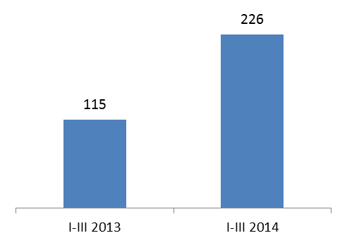

Refining and Marketing, including Retail – Clean CCS-based EBITDA amounted to HRK 268 mln loss, which is HRK 85 million below previous quarter performance.

Main drivers of the negative difference were:
- lower R&M spread deriving from 27% lower average crack spread (especially lower LPG and gasoil crack spreads),
- decreased sales volumes by 15% combined with less favourable sales structure (higher fuel oil share produced)
- higher energy consumption.

These factors were partially offset by lower operating expenses coming from decreased transportation cost, and improved Brent-Ural spread (1.4 in Q1 vs. 0.5 USD/bbl in Q4).

Total sales volumes of Retail Segment in Q1 2014 amounted to 196 kt, in comparison to the same period of the previous year was increased by 2% while throughput per site was also higher by 2%.

Capital expenditures in Q1 2014 were slightly higher than in the same period of 2013 and amounted to HRK 46 million. One of the projects that are prepared in R&M in this quarter is the turnaround in Sisak Refinery which has the objective to ensure safe, reliable, and efficient operation in Sisak Refinery.

Refining and marketing CAPEX (including Retail)
(HRK million)
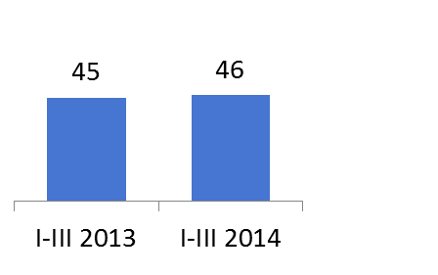

Retail capital expenditures focused primarily on the modernization and capital reconstruction of petrol stations within the project “Blue concept”, and amounted to HRK 18.5 million.

INA Group net debt decreased by 2% and amounted to HRK 4,687 million compared to 31 December 2013. Gearing ratio decreased from 27.0% as at 31 December 2013, to 26.2% as at 31 March 2014.

Net indebtedness of Gearing ratio of INA Group
INA Group
(HRK million)

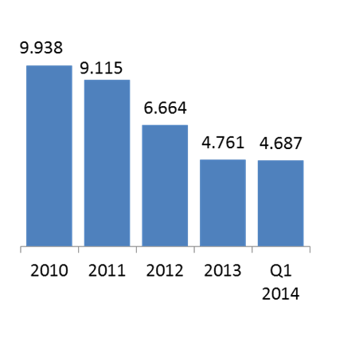
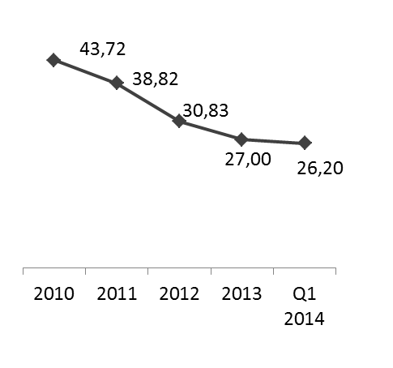

(%)

EBITDA = EBIT + Depreciation + Impairment + Provisions
Net debt / net debt plus equity incl. minority interests
CCS (current cost of supplies) is a result adjusted for changes in the price of feedstock in a way that these expenses are calculated at single price at the end of the reporting period (regardless of price changes over the period).
Net debt / net debt plus equity incl. minority interests

