FINANCIAL RESULTS
Q1-Q3 2016

Contact:
INA
Corporate Communications Sector
Avenija Većeslava Holjevca 10, Zagreb

Public Relations Department
E-mail: PR@ina.hr
Press Centre at www.ina.hr

INA published financial results for Q1-Q3 2016

Key achievements
- INA Group’s CCS EBITDA, excl. special items, amounted to HRK 1,559 million
- Crude oil production up by 11% compared to Q1-Q3 2015
- Total CAPEX amounted to HRK 968 million, out of which 90% invested in Croatia
- INA invested in acquisition of Energopetrol

Zagreb, October 28, 2016 – INA Group’s EBITDA in Q1-Q3 2016, excl. special items, reached HRK 1,568 million, while the CCS EBITDA, excl. special items, amounted to HRK 1,559 million. Net profit, excl. special items, amounted to HRK 457 million. CAPEX reached HRK 968 million, meeting the Q1-Q3 2015 level despite the highly challenging external environment. In addition to regular business projects, INA invested in acquisition of Energopetrol.

INA results continued to improve quarter on quarter during 2016, although they still remain lower compared to the 2015 level. Having in mind that the realized hydrocarbon price decreased by 27% compared to the first nine months 2015, net profit decrease of just 10% is stable result in the current environment.

Upstream production remains the main cash generator, as oil production increased 11%, compensating for the natural decline in gas production, mainly offshore.

Refining and Marketing continues to operate in a somewhat less supportive environment, as average crack spreads almost halved compared to the corresponding period of last year. Nevertheless, CCS-based operative result of R&M (including Retail) improved significantly, amounting to HRK (37) million. Refined product sales on the regional market increased, with Slovenia leading the way with a 14% increase compared to first nine months of 2015.

The overall result was impacted by special items related to severance payments which were primarily caused by the new operating model of Retail and amounted to HRK 281 million (on EBITDA level). The financial position of the Company remains stable, with net debt and gearing ratio during the Q1-Q3 2016 period reaching HRK 3,096 million and 22.4% respectively. This was achieved through an approximately HRK 1 billion savings initiative across all Segments, which will successfully mitigate the unfavourable external environment impact due to lower oil prices and average crack spread by the end of the year. In addition to regular business projects, INA invested in acquisition of Energopetrol, now holding management control in the company and adding value to its Retail operations.

In Q1-Q3 2016, E&P EBITDA excl. special items reached HRK 1,602 million. The result was primarily driven by lower Brent and natural gas prices which decreased as a consequence of reduced regulated gas price for households, but also due to more intense market competition. CAPEX in Q1-Q3 2016 amounted to HRK 526 million. Capital investments in Croatia amounted to HRK 452 million, whereas capital investments abroad were HRK 75 million.

In Q1-Q3 2016, R&M (including Retail) CCS EBITDA excl. special items amounted to HRK 184 million while reported EBITDA amounted to HRK (10) million. The result was impacted by external environment trends alongside internal company efforts focused on OPEX saving initiatives, diversification of crude oil portfolio, as well as by positive retail performance including the non-fuel segment, at deteriorated unit sales margins. R&M capital expenditures reached HRK 335 million, primarily driven by maintenance, compliance and investment type projects implemented in Q1-Q3 2016 during the Rijeka Refinery turnaround, together with continued investment activities in logistics development projects and equipment purchasing. Retail expenditures reached HRK 87 million, a HRK 22 million increase compared to the same period in 2015.

Statement of the President of the Management Board of INA Mr. Zoltán Áldott:
“INA delivered strong results in Q3 2016 with EBITDA excluding special items amounting to HRK 845 million, which is a 16% increase over the same period last year despite a still challenging external environment.
In the first nine months of 2016 net profit excluding special items amounted to HRK 457 million, in line with the comparable period last year. Our savings initiative which started in Q1 2016 ensured the company’s stabile financial position with gearing of 22% and enabled CAPEX delivery of almost HRK 1 billion, in line with 2015.
Domestic crude production keeps growing, by 15% compared to the same period last year. Refined product sales are at last year’s level, with even some increase on regional markets. Acquisition of Energopetrol added new value to the company’s Retail operations.
In a weak oil and gas environment with modest refinery margins, a cautious approach in regards to new investments and operative costs stays imperative. Although the financial position has significantly improved compared to previous years, it still requires attention from the management. Still, we are continuing with preparations and investments necessary for the Residue Upgrade Program in Rijeka Refinery, INA’s largest single domestic investment and one of the largest in Croatia ever.”

Operative results overview

- Group’s EBITDA was HRK 1,287 million
- Operating profit excl. special items amounted to HRK 512 million
- Capital expenditures reached HRK 968 million
- Increase of 11% in the crude oil production

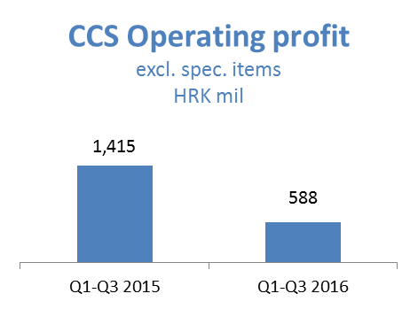
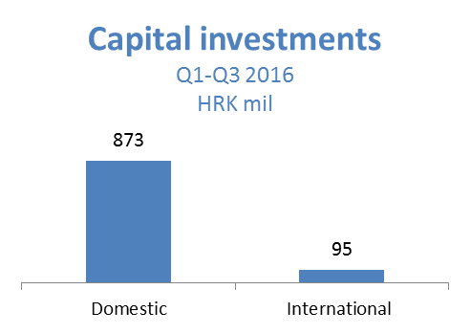

Exploration and Production – In Q1-Q3 2016, E&P EBITDA excl. special items reached HRK 1,602 million. Compared to the same period last year, Brent price in Q1-Q3 2016 was 24% lower and had a negative impact on crude oil sales revenues in the amount of HRK (366) million. Lower realised natural gas prices, as a consequence of further reduction in the regulated gas price from April 2016, and adverse market environment caused additional HRK (509) million negative effect compared to the previous year, of which HRK (103) million related to the reduction in the regulated gas price. The general overhaul of Gas Treatment Plant Molve contributed to the temporal onshore decline in Q3, but this will be offset by production start-up on the new Međimurje fields. The decline was partially mitigated by higher domestic crude oil production following well optimisation and workovers, as well as slightly higher Egyptian production. Operating profit of HRK 901 million was impacted by HRK (66) million of Egyptian receivables’ impairment.

- Hydrocarbon production decreased by 4%, but the drop was mitigated by strong domestic crude production which went up by 15% compared to Q1-Q3 2015
- CAPEX in Q1-Q3 2016 amounted to HRK 526 million. Capital investments in Croatia amounted to HRK 452 million whereas capital investments abroad were HRK 75 million.
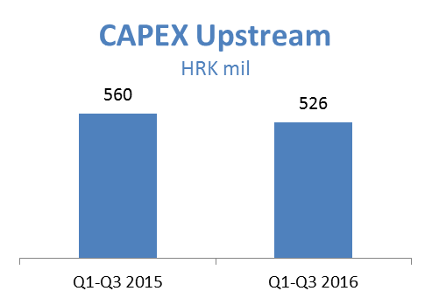
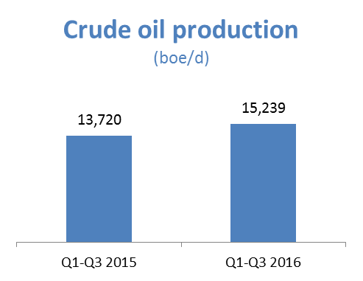
Refining and Marketing, including Retail – In Q1-Q3 2016, the segment’s CCS-based EBITDA excl. special items amounted to HRK 184 million, while reported EBITDA result amounted to HRK (10) million, an increase of HRK 359 million compared to the same period of last year. The result was mainly driven by lower DTD Brent price and higher sales on captive market, in a slightly less favourable refining margin environment. The trend was additionally supported by on-going efficiency efforts resulting in lower fixed OPEX and lower energy costs. Additionally, the result was negatively affected by lower export sales volumes with a decrease in sales margins. Starting from July 1, 2016, Energopetrol was integrated to INA Group Retail segment.

- Total CAPEX amounted to HRK 422 million; HRK 335 million in R&M and HRK 87 million in Retail
- Revenues in Refining and Marketing, including Retail, amounted to HRK 9,124 million in Q1-Q3 2016
- On September 30, 2016, INA Group operated a network of 495 Retail sites (387 in Croatia, 101 in Bosnia and Herzegovina – 45 in Holdina and 56 in Energopetrol, 6 in Slovenia and 1 in Montenegro), of which 60 Retail sites in Croatia were included in the Entrepreneurship model.
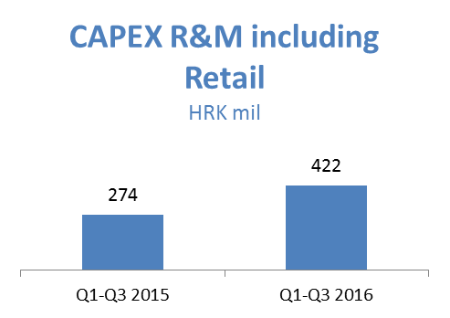
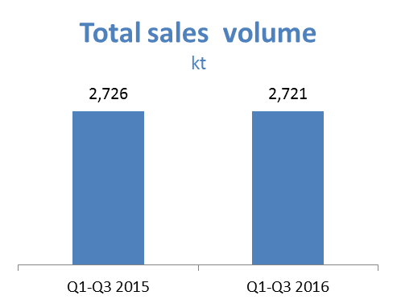

Net debt is slightly over Q1-Q3 2015 figures and amounts to very safe HRK 3,096 million with gearing ratio of 22.4.
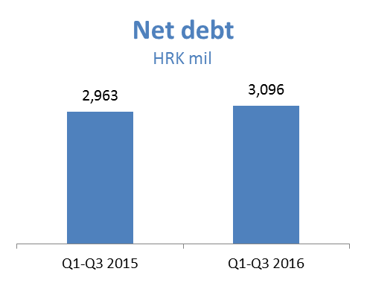
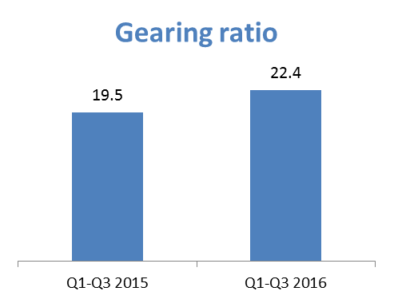

CCS (current cost of supplies) is a result adjusted for changes in the price of feedstock in a way that these expenses are calculated at single price at the end of the reporting period (regardless of price changes over the period).
EBITDA = EBIT + Depreciation + Impairment + Provisions

