FINANCIAL RESULTS
H1 2017

Contact:
INA
Corporate Communications
Avenija Veceslava Holjevca 10, Zagreb

Public Relations
E-mail: PR@ina.hr
Press Centre at www.ina.hr

INA’s growth accelerated in Q2 2017

Key achievements
- INA Group’s EBITDA amounted to HRK 1,398 million, 168% above the level in H1 2016, while net profit amounted to HRK 861 million
- Net debt down to HRK 2,026 million and gearing at a historically low level of 15.3%
- CAPEX amounted to HRK 520 million
- Domestic crude production remains stable, while domestic gas production onshore went up by 6% in relation to H1 2016
- Refinery production increased by 34%, and refined product sales grew by 23%

Zagreb, July 27, 2017 – The strong growth witnessed during Q1 2017 accelerated in the second quarter. EBITDA grew by 168% in H1, reaching HRK 1,398 million for the period, while net profit exceeded HRK 860 million, the best H1 result since 2011. Although Exploration & Production remained the main contributor to the results, Refining & Marketing incl. Retail saw the biggest improvement in its performance indicators.

For Exploration & Production, a more favorable external environment managed to offset a slight decrease in production, resulting in 26% higher EBITDA compared to H1 2016. Refining & Marketing incl. Retail benefited from a period of favorable crack spreads which, alongside higher processing levels and strong Retail performance, pushed EBITDA into positive territory, reaching HRK 183 million for the first half year. Retail sales in both the fuel and non-fuel segments showed a record increase.
CAPEX amounted to HRK 520 million, impacted by different schedule of investments during the year, where a more intensive investment campaign is expected in the second half of 2017. Net debt decreased to HRK 2,026 million with gearing going to historically low level of 15.3%.

President of the Management Board of INA Mr. Zoltán Áldott said: “H1 2017 showed a respectable growth for INA results across all business operations. All main indicators are improved with EBITDA increasing from HRK 521 mn in H1 2016 to HRK 1.398 mn in H1 2017 while net profit, excluding one off items, jumped to HRK 608 mn from HRK 70 mn in H1 2016.
2016 efficiency program continued to show visible results in 2017 while favourable external environment brought additional relief. Combined, it led to the lowest indebtedness in the last decade and the ability of INA to finance all main strategic projects in forthcoming period.
Upstream results benefited from the improved external environment with modest growth of Brent and gas prices, while natural decline was slowed down by successful growth projects: EOR project and higher production from new wells Selec and Đeletovci Zapad. Combined with the efficiency program it led to the improved financial result.
Still, Upstream growth was surpassed by Downstream improvements. Significantly higher R&M processing levels further supported by more favorable margins drove the Downstream result to a positive area in EBITDA terms, but the cash flow still stays negative.
Retail maintains good results with regional network growth together with non-fuel expansion assuring constantly strong results.
It is worth to mention stabilized performance of our oil services activities, which were strongest hit by halved Brent prices in the past several years. Crosco reported positive EBITDA in H1 2017.
This relief period should also be used for further strengthening of the market position and operations, as long term outlook is difficult to make and the volatility of the market can once again prove challenging.”
Operating results overview

- Group’s EBITDA was HRK 1,398 million
- Operating profit amounted to HRK 910 million
- Net profit amounted to HRK 861 million
- Capital expenditures reached HRK 520 million
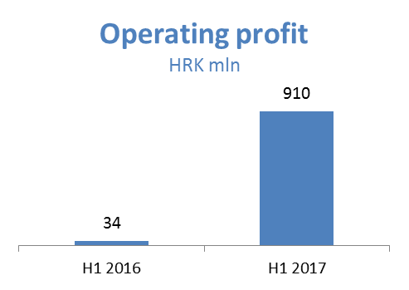
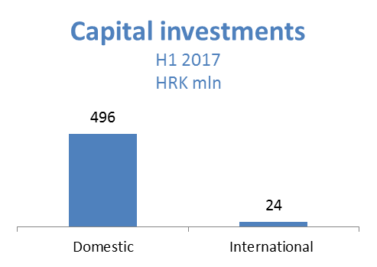
Exploration and Production – In H1 2017, EBITDA reached HRK 1,302 million, 26% more than in H1 2016. The 30% higher Brent price had a positive effect on oil and condensate sales revenues in the amount of HRK 266 million, while lower realized gas prices caused a HRK (73) drop in revenues. Domestic crude oil production is at 2016 levels mainly thanks to the positive effect of full field optimization and the EOR projects, as well as higher production from new wells, but the result was partially offset by natural decline and problems with the Hrastilnica field pipeline. Natural gas production drop was offset by 6% higher onshore natural gas production mainly as a result of production from Međimurje fields. CAPEX amounted to HRK 259 million, out of which HRK 252 million in Croatia.
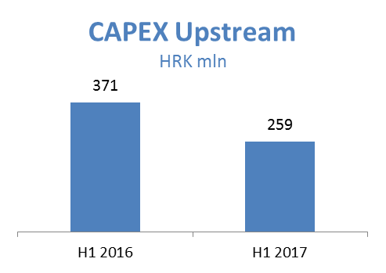
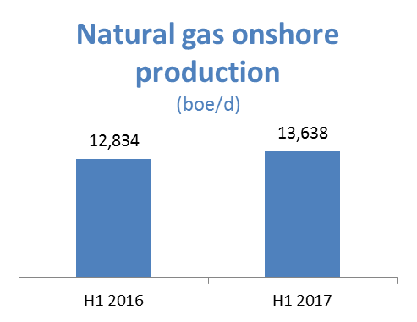
Refining and Marketing, including Retail – H1 2017 EBITDA amounted to HRK 183 million, while operating loss amounted to HRK (57) million compared to the H1 2016 loss of HRK (298) million. Revenues amounted to HRK 7,196 million, 44% more than in H1 2016. The result was impacted by a number of factors: favorable external environment driven by stable DTD Brent price, higher diesel crack spread and more favorable fuel oil spread which impacted refining margins positively. Also, total sales volumes increased on the back of higher sales on both captive and other export markets. Higher refining margins and sales demand resulted in higher processing levels in refineries. Retail sales volumes grew mainly thanks to network expansion with Energopetrol consolidation and further assisted with active sales of Class Plus fuel (started in Q2 2017). Non-fuel margin increased on the back of continuous investment and development activities in goods segment, contributing 21% to total Retail margin. Total CAPEX amounted to HRK 244 million; HRK 205 million in R&M and HRK 39 million in Retail. On June 30, 2017, INA Group operated a network of 494 retail sites.
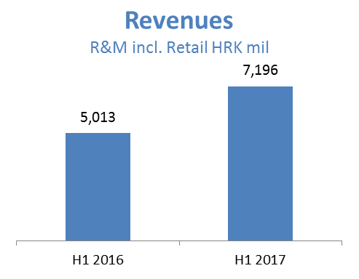
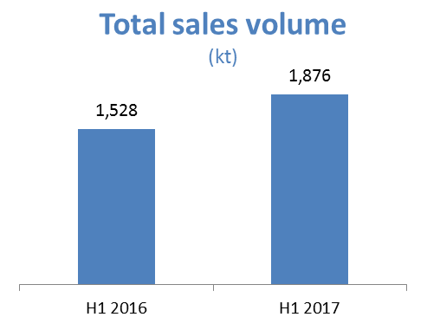
Net gearing amounted to 15.3%, whilst net debt reached HRK 2,026 million.
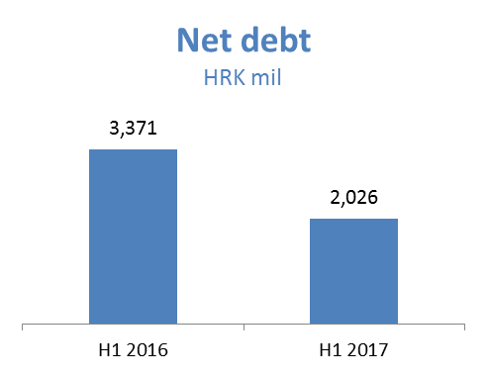
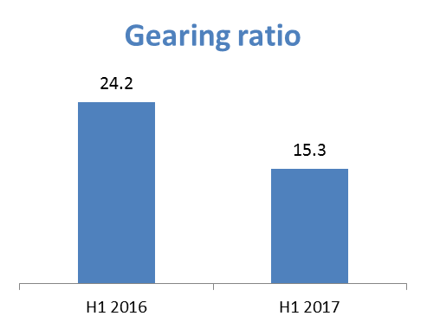

EBITDA = EBIT + Depreciation + Impairment + Provisions

