FINANCIAL RESULTS
Q1-Q4 2017

Contact:
INA
Corporate Communications
Avenija Veceslava Holjevca 10, Zagreb

Public Relations
E-mail: PR@ina.hr
Press Centre at www.ina.hr

INA: strong operating performance in 2017

Key achievements
- INA Group’s EBITDA amounted to HRK 3,215 million, 52% above the level in 2016, while net profit amounted to HRK 1,220 million
- Net debt at HRK 1,397 million and gearing at 10.8%
- CAPEX amounted to HRK 1,393 million
- In relation to 2016, both domestic crude production and domestic gas production onshore registered a mild increase of 2 and 3% respectively

Zagreb, February 20, 2018 – INA Group realized an increase in revenues across all segments, with a 20% growth compared to 2016 levels. This increase, together with results of optimization measures from past periods, led to HRK 3,215 million EBITDA, representing a substantial 52% increase from 2016. Such a robust operating performance was also reflected in net profit surging to HRK 1,220 million in 2017, compared to HRK 101 million in 2016.

Exploration & Production benefited from the positive external environment with 24% higher Brent price, which together with higher realised gas prices and a slight increase in domestic on-shore production contributed to the 42% uplift in operating profit to HRK 1,666 million.

Refining & Marketing incl. Retail reported better financial performance, as INA was able to capture the positive external environment of higher crack spreads and increased total sales volumes with CCS EBITDA excl. special items amounting to HRK 806 million, compared to HRK 350 million in 2016. Retail sales volumes increased on the back of the network expansion in Bosnia and Herzegovina and a slight economic rebound together with positive development in premium fuels and non-fuel sales.

CAPEX performance remained strong at HRK 1,393 million, at the 2016 level, with increased spending in Croatia. At the same time net debt decreased to HRK 1,397 million and net gearing at 10.8%.

Statement of Mr. Zoltán Áldott, President of the Management Board of INA:
“In 2017 INA Group posted one of the strongest results in its recent history. We demonstrated our ability to capture the benefit of higher prices delivering strong EBITDA of over HRK 3.2 billion, a 52% increase compared to 2016.
We identified two main pillars of our operations: the first being focus on growth and the second including operational excellence and top efficiency performance. We delivered in both areas. INA’s focus on strengthening sales activities led to an increase of top line revenues by 20% compared to 2016. Thanks to oil derivatives wholesale (12% increase), retail (4% increase), as well as natural gas trading (8% increase) we improved sales value and further positioned INA as a leading player on all our key markets. Continuous efficiency measures implemented in the last two years were the basis on which we were able to deliver new value even in a low price environment. CAPEX spending stayed robust at level of HRK 1.4 billion, in line with the previous year and with an increase on investments in Croatia.
We generated strong free cash flow on the back of our integrated business model, with significant contribution of our Upstream business, which benefited from the positive external environment together with a moderate increase in domestic crude oil production. Although we are faced with natural decline of our mature fields, we made significant efforts in increasing production on our mature domestic oil fields, exploiting the maximum potential by implementing the Full Field Optimization (FFO) concept and performing various well activities with success. This resulted with an increase of domestic crude oil production back to levels seen 10 years ago.
Downstream business generated strong EBITDA with positive cash flow, the strongest result in a decade, demonstrating not only our ability to capture positive environment of higher crack spreads, but also our efforts in number of other operating activities and efficiency measures. These activities resulted in an introduction of two new fuels, a strong position on the Croatian market, increased sales on all markets, record volumes in Rijeka logistics, with strong focus on safety and environment. One of the major challenges in front of us is pursuing options which will make our Refining and marketing business sustainable and profitable in the long run. With that in mind, we need to emphasize Sisak refinery results which continue to burden INA’s R&M performance with a negative operating result of HRK (207) million loss in 2017 and HRK (264) million loss in the previous year.
We believe that having a quality refining portfolio together with high quality services within our retail network is the core to our vertically integrated business model, as it provides optimization opportunities in this highly competitive market. This is why we continually invest in introduction of new and additional services at our service stations, tailored to needs and requirements of our customers.
Although we significantly improved our financial position bringing net debt to a historical year low, it still requires a lot of effort to be continually prepared for quick adjustments and to be able to successfully manage all the businesses in the environment of uncertainty, complexity and volatility.”

Operating results overview

- Group’s EBITDA was HRK 3,215 million
- Operating profit amounted to HRK 1,418 million
- Net profit excluding special items amounted to HRK 1,181 million
- Capital expenditures reached HRK 1,393 million
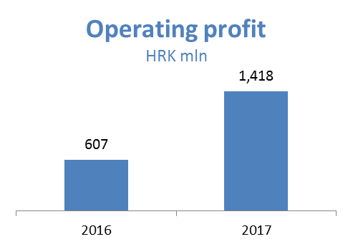
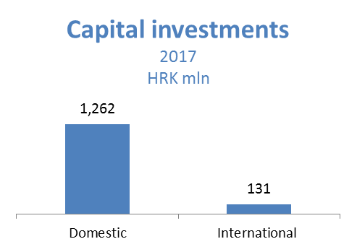

Exploration and Production – In 2017, EBITDA reached HRK 2,474 million, 16% more than in 2016. The 24% higher Brent price had a positive effect on oil and condensate sales revenues in the amount of HRK 419 million, while higher realized gas prices, together with customer base increase, resulted in a HRK 14 million increase in revenues. Domestic crude oil production improved as a result of additional development projects and the EOR project, as well as start-up of two new wells in Hrastilnica. Natural gas production drop was partially offset by 3% higher onshore natural gas production mainly as a result of full year production from Međimurje fields, positive impact of the EOR project and additional development projects. CAPEX amounted to HRK 618 million, out of which HRK 597 million in Croatia.
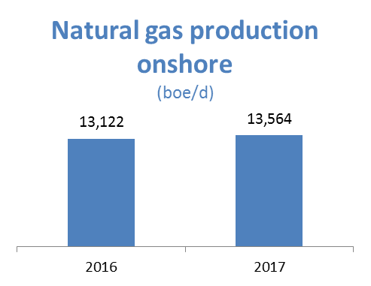
Refining and Marketing, including Retail – 2017 EBITDA amounted to HRK 987 million, while operating profit amounted to HRK 263 million. Revenues amounted to HRK 16,138 million, 24% more than in 2016, thanks to focus on increase in sales activities. The result was impacted by a number of factors: total sales volumes increased on the back of higher sales on both captive and other export markets, while capturing market opportunities and favorable external environment enabled increased processing in the refineries to support increased total sales. Also, a more favorable external environment, higher diesel and gasoline crack spread and a less negative fuel oil spread resulted in improved refining margins, while Brent prices averaged 54 USD/bbl. Retail sales volumes grew due to the significant contribution of network expansion in BH supported by introduction of new Class Plus fuels in Q2 2017.
In spite of the improved Refining & marketing incl. Retail result, it remained burdened by the negative effect of Sisak refinery operations. The financial effect of Sisak Refinery on operating result level amounts to HRK (207) million loss in 2017 and HRK (264) million loss in previous year. Also, during 2017 Sisak Refinery generated negative free cash flow of HRK (125) million, compared to HRK (194) million in 2016.
Total CAPEX amounted to HRK 713 million; HRK 550 million in R&M and HRK 163 million in Retail. On December 31, 2017, INA Group operated a network of 494 retail sites.
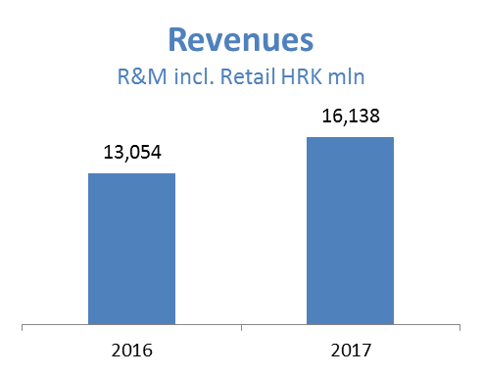
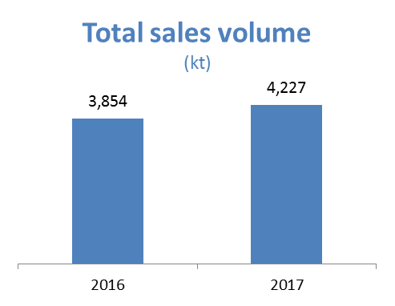
Net gearing amounted to 10.8%, whilst net debt reached HRK 1,397 million.
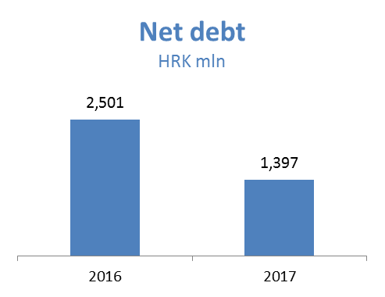
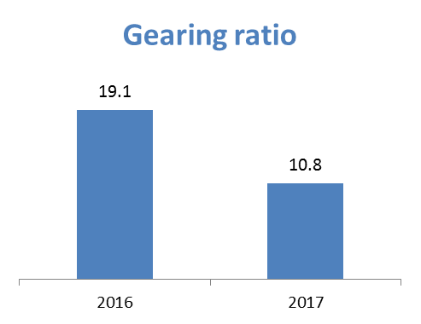

EBITDA = EBIT + Depreciation + Impairment + Provisions
In 2017, EBITDA was positively impacted by HRK 4 mn related to reversal of provision in Angola, while EBIT was positively influenced by HRK 40 million net effect of reversal of provision in Angola, Crosco assets impairment and Environment related provision; 2016 EBITDA was negatively influenced by HRK 315 million special items related to Severance payments

