FINANCIAL RESULTS
H1 2019

Contact:
INA
Corporate Communications
Avenija Veceslava Holjevca 10, Zagreb

Public Relations
E-mail: PR@ina.hr
Press Centre at www.ina.hr

INA has doubled its investments in Croatia in H1 2019

Key achievements
- INA Group’s EBITDA amounted to HRK 1,122 million
- Net sales revenues increased by 3% and amounted to HRK 9,794 million
- CAPEX amounted to HRK 1,183 million and increased by 128%
- Operating cash flow amounted HRK 1,009 million

Zagreb, July 26, 2019 – In H1 2019, INA Group revenues totaled at HRK 9,794 million while CCS EBITDA excluding special items amounted to HRK 1,175 million. Profit reached HRK 188 million, driven mainly by lower refining margin environment.
Exploration and Production EBITDA decreased by 14% to HRK 1,238 million on the back of lower hydrocarbon price and slight decrease in hydrocarbon production. However, crude oil production was higher in Croatia and Egypt, driven by increased development activities and higher investments.
Refining and Marketing including Consumer Services and Retail CCS EBITDA excluding special items turned to negative HRK (10) million. The main result driver was the deteriorated refining environment. Retail volumes increased by 4% as a result of better performance in Croatia and network expansion in Montenegro.
Nevertheless, H1 2019 was an investment intensive period. CAPEX more than doubled compared to the same period last year and amounted to HRK 1,183 million, mainly driven by refining investments. Investments in Croatia amounted to HRK 992 million, more than double compared to the same period last year. Net gearing amounted to 14%, whilst net debt is at HRK 1,763 million, reflecting a very strong balance sheet.

Statement of Mr. Sándor Fasimon, President of the Management Board of INA:
“First half of 2019 was a period of intensive investment for INA. Total investments reached almost HRK 1.2 billion, majority of which was spent domestically. Refining capital expenditures more than tripled compared to the same period last year, to more than HRK 800 million, mainly related to the Rijeka Refinery turnover, one of the largest ones in the company’s history. During this turnover, the main column on Crude Distillation Unit has been replaced, as well as numerous other works were completed, with the aim of sustainable and efficient refining operations. This investment shows INA’s commitment to further development of its refining segment, together with additional activities in INA's Downstream 2023 New Course program.
Less favorable external environment, had negatively impacted the results, but INA still managed to capture higher demand both domestically and in Bosnia and Herzegovina.
Retail continued its growth in non-fuel segment, but also benefited from the expanded Montenegro network, demonstrating the strength of INA brand as customers’ first choice throughout the regional markets. As for Upstream, crude production increase partially offset the lower natural gas production. Overall crude production increase continues to be driven by not just domestic oil production increase, but also by additional production in Egypt, coming from increased investments. Still, the Brent price decrease of 7 % lowered the segment results compared to the same period of 2018. Despite the challenging environment INA Group total revenues recorded a 3% increase, amounting to almost HRK 10 billion.
INA’s financial position stays strong with a positive outlook for H2 2019.”

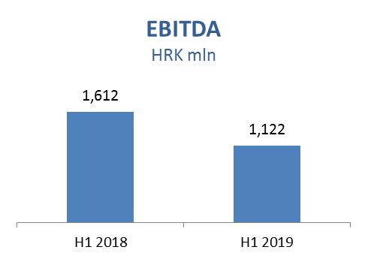

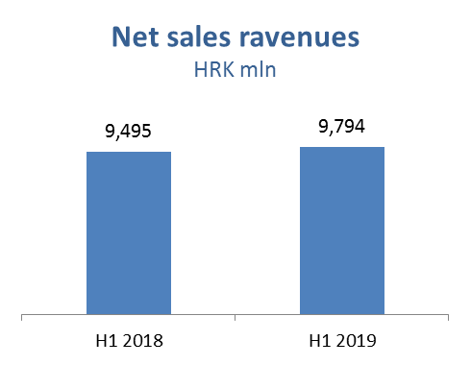

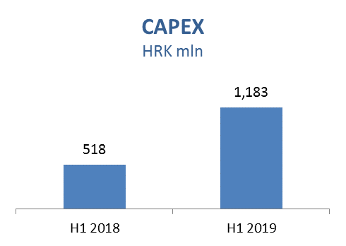

Exploration and Production – In Q1 2019, net sales revenues slightly increased and amounted to HRK 1,985 million, despite the 7% lower Brent price which had a negative effect on crude oil. Domestic crude oil production is slightly higher as a result of performed well workovers, well optimization and more favorable EOR project increment on Ivanić field. CAPEX increased by 10% and amounted to HRK 306 million, out of which HRK 204 million in Croatia. Higher investment level is realized mostly due to exploration drilling and development activities in Egypt and well workovers performed in Croatia.
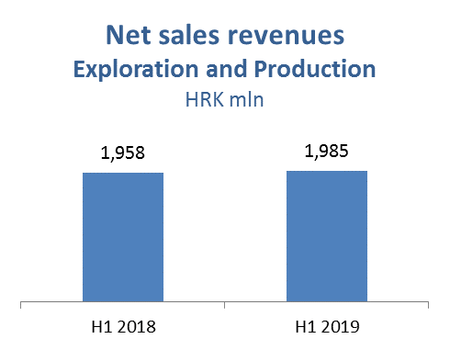

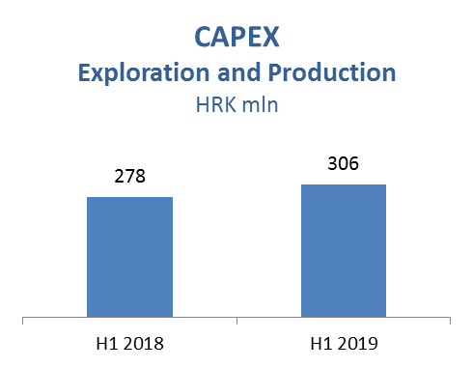

Refining and Marketing, including Consumer Services and Retail – In H1 2019 net sales revenues slightly increased and amounted to HRK 9,286 million. The result was driven by a number of factors: lower Brent price, decreased gasoline and LPG crack spreads and slightly higher diesel crack spread. Furthermore, lower processing due to the Rijeka Refinery turnaround, increased wholesale volumes and decreased sales of fuel oil on export markets also affected the result. Total retail sales volumes at 502 kt improved by 4% compared to the same period in 2018, with a significant contribution from Croatian and Montenegrin markets.
Total CAPEX increased by 261% and amounted to HRK 845 million; HRK 722 million in R&M, mainly driven by Rijeka Refinery turnaround, and HRK 123 million in Consumer Services and Retail driven by various investment projects and expanding the non-fuel offer in line with the Fresh Corner concept.
On June 30, 2019, INA Group operated a network of 507 service stations.

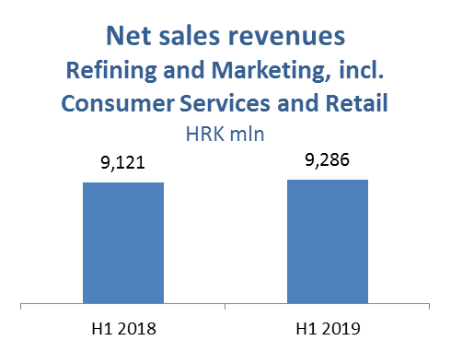

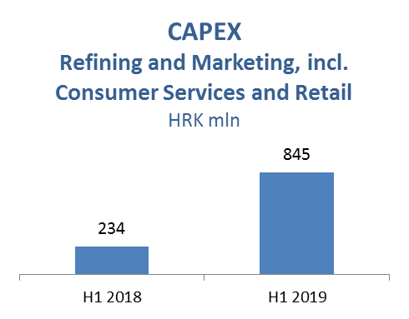

EBITDA = EBIT + Depreciation, amortization and impairment (net)
Profit for the period excluding special items

