FINANCIAL RESULTS
H1 2020

Contact:
INA
Corporate Communications and Marketing
Avenija Većeslava Holjevca 10, Zagreb

Public Relations
E-mail: pr@ina.hr
Press Centre at www.ina.hr

External circumstances continued to affect the INA Group financial results

Key achievements
- Net sales revenues amounted to HRK 7,080 million
- CCS EBITDA excl. special items amounted to HRK 813 million
- CAPEX amounted to HRK 518 million
- Net Operating Cash Flow amounted to HRK 602 million

Zagreb, July 28, 2020 – Following the unforeseen and unprecedented market turmoil during the first half of 2020, INA results dropped compared to 2019 results. With the easing of restrictive measures connected to COVID-19 pandemic, the global oil market has stabilized, but the oil & gas industry is far from full recovery.
CCS EBITDA of INA Group amounted to HRK 813 million, which is a 31% decline compared to the same period in 2019. However, the Q2 2020 result is at a similar level as Q1 2020, reflecting the recent recovery of hydrocarbon prices and stable internal operations. The reported result is still negative, but significantly less than in Q1 2020, with EBITDA of HRK (54) million, driven by external environment impact.
Exploration and Production result has been impacted by the combination of 12% lower production due to natural decline and 35% lower realized hydrocarbon prices, having the EBITDA to HRK 554 million compared to H1 2019.
Refining and Marketing including Consumer Services and Retail CCS EBITDA excluding special items is positive at HRK 185 million on H1 2020 level, driven by healthy Retail performance. Still, the reported EBITDA shows a negative trend with HRK (682) million in line with the unfavorable price environment. The pandemic and the decline in tourism resulted in a 16% drop of Retail sales volumes, while the non-fuel revenues continue to increase.
While the strategic transformation of Refining and Marketing business continues, CAPEX amounted to HRK 518 which is lower compared to H1 2019 due to the high base effect, as a major turnaround in the Rijeka Refinery in 2019 boosted investments last year. Also the CAPEX was reduced following necessary measures made in light of the economic crisis driven by COVID-19 pandemic.
Net gearing amounted to 20% with net debt standing at HRK 2,543 million at the end of H1 2020.

Statement of Mr. Sándor Fasimon, President of the Management Board of INA:
“2020 continues to prove itself as one of the most challenging years for oil & gas industry. Following the outbreak of COVID-19 pandemic many countries implemented gradual easing of restrictive measures which helped move the economy from a standstill. But for oil & gas industry recovery is still not near, since demand returned only partially and the price levels, especially of gas, remain too low for many assets to operate profitably.
In such unforeseen conditions INA took swift operative and financial measures to adapt its operations, most significant being further streamlining of operations, reducing OPEX and postponing non-critical investments. Only with such strong reaction can we maintain our stability and ensure sufficient cash flow for strategic investments in the coming years. Most of these strategic investments, which are continuing regardless of crises are focused in our refining segment as part of INA Downstream New Course 2023.
In regards of the H1 2020 operations, we can say they are stable on operational level, with CCS EBITDA of HRK 813 million, but the challenging market conditions and external factors drove reported EBITDA to negative HRK (54) million. Although negative, when comparing the results with Q1 2020, result of somewhat improved price environment and our internal efforts is visible. Exploration and Production remains pressured by expected natural production decline, further pushed down by the low hydrocarbon prices. Refining on the other hand, despite lower Brent price as an upside has to deal with large demand drop caused by lower economic activity and negative margins. Retail also witnessed its share of demand decrease, but company continues its expansion of non-fuel segment and quickly reacts to market movements.
In a market this volatile any predictions on the future would be hard to make, but with the continuation of strategic development projects, while keeping an eye on internal efficiency I am confident INA will come out of the crisis as a stronger company, more adapt to the future trends.”

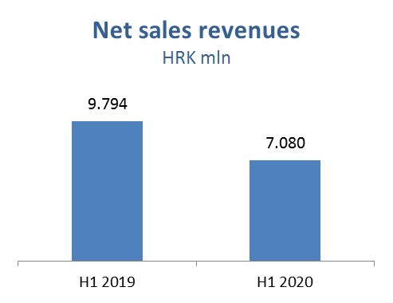

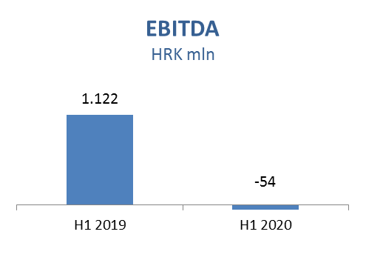

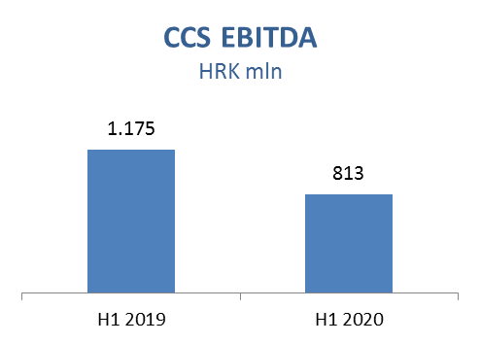

Exploration and Production – Net sale revenues in H1 2020 decreased and amounted to HRK 1,180 million, while CAPEX amounted HRK 184 million, out of which HRK 129 million in Croatia.
Domestic crude oil production was lower as a result of natural decline and increased water cut mainly on Đeletovci and Stružec fields. However, crude oil production in Egypt increased by 1% in H1 2020, supported by drilling activities on North Bahariya. Average hydrocarbon price decreased by 36% negatively impacting sales revenues.

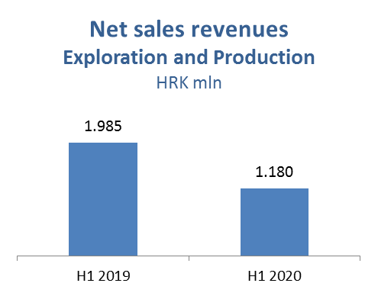

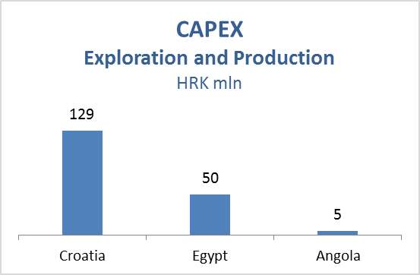

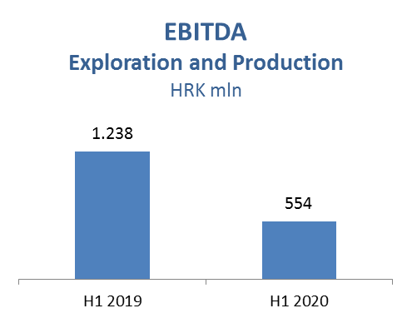

Refining and Marketing, including Consumer Services and Retail – In H1 2020 net sales revenues decreased by 27% and amounted to HRK 6,812 million. CCS EBITDA excluding special items amounted to HRK 185 million, mainly driven by higher share of own product sales, strong sales margins on core markets and disciplined cost saving measures, offsetting decreasing economic activity and lower demand for refined products. Refinery margin remained under pressure due to less favorable diesel and gasoline crack spreads, while lower crude oil prices and lower energy costs had a positive impact on the segment.
Processing was higher in H1 2020 by 515 kt due to longer turnaround in Rijeka Refinery in H1 2019. Refined product sale increased by 13% and amounted to 1,970 kt.
Still, total Retail sales volumes at 420 kt decreased 16% compared with the same period last year, affected by lower demand starting form the second half of March after the Covid-19 outbreak and nationwide lockdown, as well as drop in tourist consumption and arrivals.
Non-fuel margin increased by 15%, reflecting continuous expansion in consumer goods and services.
Total CAPEX amounted to HRK 303 million; HRK 250 million in R&M, mainly driven by Residue Upgrade and Propane-Propylene Splitter projects, as well as Biorefinery project, and HRK 53 million in Consumer Services and Retail driven by various investment projects and expanding the non-fuel offer in line with the Fresh Corner concept.
On June 30, 2020, INA Group operated a network of 508 service stations.

