FINANCIAL RESULTS
H1 2022

Contact:
INA
Corporate Communications and Marketing
Avenija Većeslava Holjevca 10, Zagreb

Public Relations
E-mail: pr@ina.hr
Press Centre at www.ina.hr

Capital investments doubled with stronger results

- High hydrocarbon price levels have continued, reflecting the increased geopolitical risk and uncertainty affecting global energy markets.

- In such environment, results show a strong INA Group CCS EBITDA in H1 2022.

- Exploration and Production revenues and EBITDA doubled, significantly overcompensating the effect of expected natural production decline.

- Investment activities intensified and CAPEX spending increased twofold compared to H1 2021 with CAPEX level of HRK 1.3 billion:

  - Rijeka Refinery Upgrade Project, as the main strategic investment, continues with construction works and equipment delivery to the site.

  - Many Production and Exploration development activities in Croatia, both offshore and onshore.

Key data:
- Net sales revenues amounted to HRK 15.6 billion
- EBITDA amounted to almost HRK 2.8 billion
- CAPEX more than doubled compared to H1 2021, to HRK 1.3 billion
- Despite the strong result operating cash flow amounted to HRK -635 million, due to intensified capital investment spendings and high oil and gas prices on the market

Zagreb, July 29, 2022 – Due to geopolitical risks and supply uncertainties, global energy markets continued to be marked by high prices, with Brent levels above USD 100 per barrel and CEGH gas price exceeding 100 EUR/MWh in Q2 2022.
Driven by the favourable price environment, results remained strong. H1 2022 INA Group CCS EBITDA excl. special items amounted to more than HRK 2.4 billion while net profit exceeded HRK 1.5 billion. Results improved throughout the segments with Exploration and Production revenues of almost HRK 3 billion and EBITDA of HRK 2.1 billion. High realized hydrocarbon prices significantly overcompensated the effect of continued natural decline of production. Negative cash flow of Refining and Marketing incl. Consumer services and Retail segment caused by ongoing investment activities is mitigated by the improved CCS EBITDA performance of almost HRK 0.8 billion. High energy prices and government restrictions in Retail prices and margins at the same time had a negative impact on the result. Non-fuel growth continued with 15% increase in margin driven by expanded offer and improved sales activities.
Intensified investment activities continued, CAPEX spending more than doubled compared to H1 2021 and reached HRK 1.3 billion, of which almost a billion spent in Refining and Marketing. Aimed at moderating trend of natural production decline, Exploration and Production also increased CAPEX level, focusing on development activities, both onshore and offshore. Despite the strong operative results, the cash flow of the company in H1 2022 was negative, because of the increased investments and the unprecedented financing need of the working capital due to the global energy price levels.
Statement of Mr. Sándor Fasimon, President of the Management Board of INA:
“2022 continue to be a challenging year for the global economy, with market turmoil in many areas, especially in the energy sector. High level of both oil and gas prices, together with uncertainty in the safety of supply, have led to government interventions in many countries. Rise in the prices pushed the revenues of the entire oil and gas industry but various regulatory decisions on the other hand create a position where future trends are not easy to foresee.

INA’s result in such environment stayed strong, with Exploration and Production bringing the biggest contribution to the result. Production declines as expected in line with the mature portfolio, but multiple development activities aimed at moderating natural decline are underway, both onshore and offshore.

Due to the mentioned global risks and lower product availability, refining margins improved greatly and supported the result of the Refining and Marketing, including Customer Services and Retail, despite the regulatory constraints on price and margins. In these circumstances INA’s priority is the safe supply of the market, which is ensured with no major disturbances in the supply. Seasonality of Croatian market is visible with growth of Retail volumes, not just in fuel but also in non-fuel segment. Considering all the above factors INA’s EBITDA exceeded HRK 2.7 billion in first half 2022. Tourist season is in full swing and the Q3 result will likely show even stronger result, providing the regulatory measures don’t additionally impact the market.

Apart from the strong revenues INA is also in a period of high investments. Capital expenditure more than double compared to first half 2021 and exceeded HRK 1.3 billion, of which more than a billion in the Refining segment. Rijeka Refinery Upgrade Project total completion is at more than 50% and continues as one of the largest investments in recent years, not just on INA level but also on country level. With the completion of the project supply of the domestic and core markets will be not just safe but also significantly more economically sustainable.”

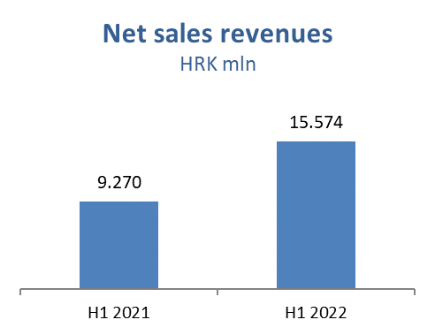

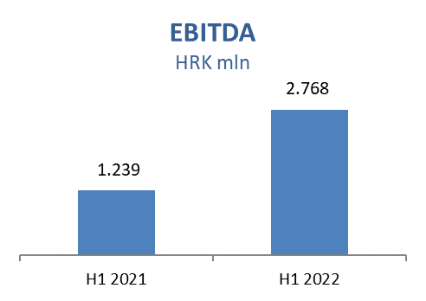

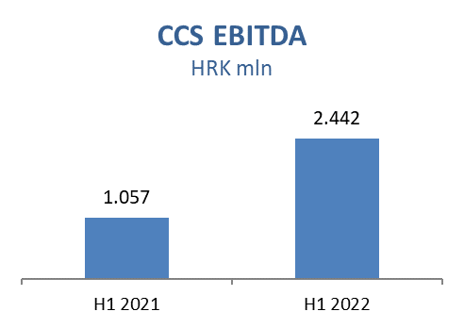

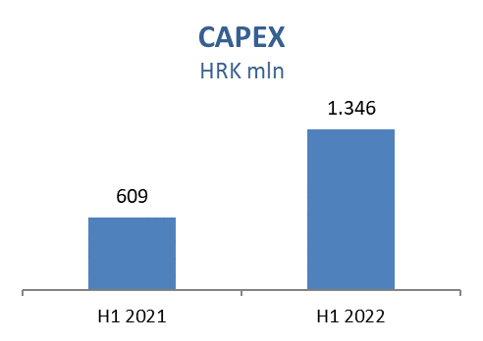

Exploration and Production
Higher prices impacted sales revenues positively by HRK 1.3 billion. Increased gas prices added HRK 715 million positive effect, while 66% higher Brent price brought an additional HRK 492 million crude oil and condensate sales revenues with other products positive impact on revenues in the amount of HRK 109 million.

Higher CAPEX level compared to H1 2021 mainly as a result of development activities on Croatia Offshore drilling campaign and on Croatia Onshore. Main activities in H1 2022:

Croatia Exploration:
- Drava-03: Permitting and preparation for drilling underway
- SZH-01: Seismic interpretation, geochronological study and laboratory analysis in progress
- DI-14: External G&G study completed, final G&G in-house study completed

Croatia Development Offshore:
- Ika B-1 R well: initial production started on March 3, 2022
- Marica D Dir well: Hook up completed. Trial production started on May 26, 2022

Croatia Development Onshore:
- In total 25 workovers were performed
- Dravica-3: Drilling started on April 18, finished on May 31, 2022, the well is negative. Based on results, review of surface production concept is in progress
- EOR Šandrovac: finished CO2 injection phase; start of water injection at beginning of April and it is ongoing

Egypt:
- Egypt, North Bahariya concession: 7 development wells drilled (3 producers and 4 water injectors), out of which 2 put in production as oil producers, third drilled oil well completion in progress.
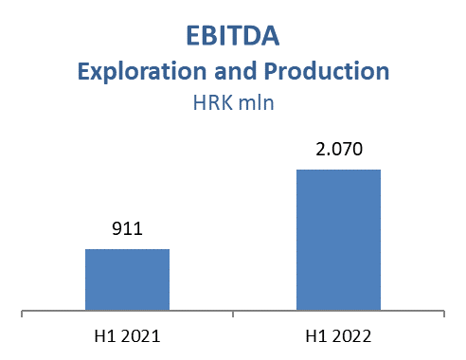
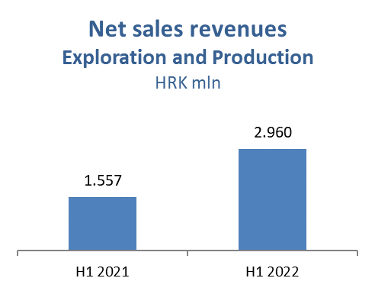

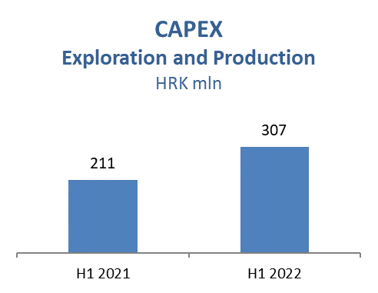

Refining and Marketing, including Consumer Services and Retail
Captive market sales was higher, with commercial margins under pressure due to government price regulations on domestic market. Rijeka Refinery operation started end of March ensuring stable captive market supply in the upcoming months, mitigating risk of lower product availability on global market driven by Russia-Ukraine crisis. Outstanding macro environment with elevated crack spreads strongly supporting refining contribution to the financial result in Q2, partially counterbalanced by high energy prices.

Total Retail sales volumes amounted to 508 kt in H1 2022 that is 9% above the same period of 2021, reflecting improved market conditions compared to the COVID restrictions in the past year and higher tourist consumption. Non-fuel margin increased 15% driven by expanded non-fuel offer, Fresh Corner roll-out and improved sales activities. Maintaining the leading position on the fuel market in Croatia is supported by the INA Loyalty program reaching 380 thousand registered members. Roll out of first own label products started (Crunch&Go and Jim brands).
Refining and Marketing CAPEX amounted to HRK 968 million:

- Rijeka Refinery Upgrade Project - The last main purchase order for subcontractors was awarded for Electrical and Instrumentation works. Manufactory and delivery at the site reached ~90%. Construction of the Coke Drums Structure was finished by reaching ~120 meters, allowing for heavy lifting of equipment and steel structures – final height ~190 meters. The construction of a 110kV powerline and substation ended. Total project completion is at 56%.
- CDU energy efficiency upgrade project - Preparation of main design ongoing (30% completion achieved). Ongoing tenders for main equipment delivery (heat exchangers, new pumps, overhaul of existing pumps).

Consumer Services and Retail capital investments amounted to HRK 34 million in H1 2022 with focus on service station modernization and continued roll-out of Fresh Corner concept, which is present at 130 service stations.

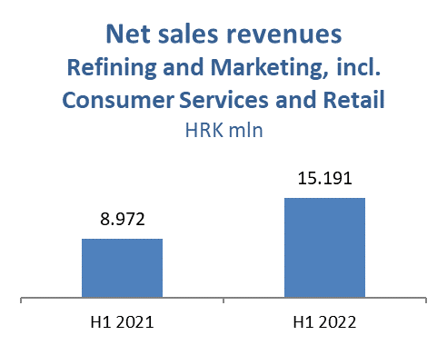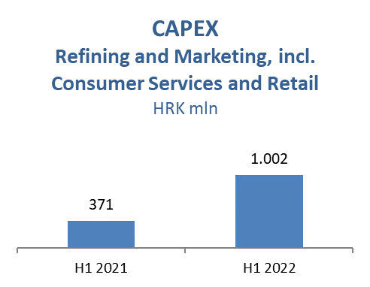
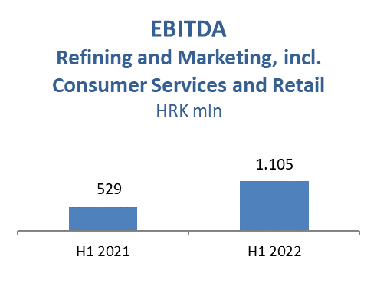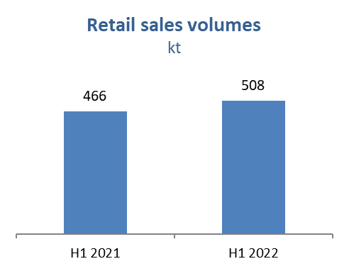

INA Group net gearing amounted to 17.2%, whilst net debt increased to HRK 2.4 billion.

