FINANCIAL RESULTS
Q1-Q3 2022

Press Contact:

INA, d.d.
Corporate Communications and Marketing
Avenija Većeslava Holjevca 10, Zagreb

E-mail: pr@ina.hr
Press Centre at www.ina.hr

INA continues to be one of the largest investors in Croatia with more than doubled capital investments

- High hydrocarbon price levels have continued, reflecting the increased geopolitical risk and uncertainty affecting global energy markets.

- In such environment, results show a strong INA Group result in Q1-Q3 2022, although various regulatory restrictions had a negative impact on Retail result.

- Exploration and Production revenues and EBITDA more than doubled, significantly overcompensating the effect of expected natural production decline.

- Investment activities intensified and CAPEX spending more than doubled compared to the same period last year, confirming INA as one of the largest investors in Croatia:

  - Rijeka Refinery Upgrade Project, as the main strategic investment, successfully continues with construction works and equipment delivery to the site.

  - Many Production and Exploration development activities in Croatia, both offshore and onshore.

- Despite the strong operative results, operating cash flow of the company is lower compared to last year, due to major investments and large financing needs for the working capital.

- Related to gas sales towards HEP, regulated at fixed price, negative impact is expected from Q4 2022.

Key data:
- Net sales revenues amounted to HRK 27.2 billion
- EBITDA amounted to almost HRK 4.7 billion
- CAPEX more than doubled, to HRK 1.9 billion

Zagreb, October 28, 2022 – Energy market turmoil driven by the geopolitical risks and supply issues continues to keep the hydrocarbon prices at elevated levels, with Brent prices above USD 100 per barrel and CEGH gas price fluctuating, but shortly exceeding even 200 EUR/MWh during the Q3 2022. In such environment, entire oil and gas industry delivers strong results.
INA Group CCS EBITDA excl. special items in first nine months 2022 amounted to more than HRK 4.7 billion while net profit exceeded HRK 2.7 billion. Results are stronger in all segments with Exploration and Production naturally being the main cash generator, mainly due to the strong environment. Exploration and Production revenues amounted to HRK 5.4 billion with EBITDA HRK 3.9 billion. Natural decline of production continues, but the effect of ongoing Offshore drilling campaign is already visible in production volumes. Ongoing investment cycle in Refining and Marketing incl. Consumer services and Retail segment caused negative cash flow although the operating results improved. Various regulatory restrictions in Retail had a negative impact on the result but on the other side the refining margins improved leading to better overall results with CCS EBITDA of almost HRK 1.3 billion.
Investment activities continue to be on high levels, throughout the segments, more than doubling compared to first nine months 2021. Refining and Marketing, with the Residue Upgrade Project remain the biggest investment segment, but the ongoing Offshore drilling campaign is also a significant development project, with the effect of increase gas production already showing.
Despite the strong operative results, operating cash flow of the company is lower compared to last year, due to major investments and large financing needs for the working capital.

Statement of Péter Ratatics, President of the Management Board of INA:

“Third quarter of 2022 brought continuation of worldwide energy market volatility, with gas prices oscillating and oil price at continued high level. Questionable security of supply in some countries, caused by the global turmoil, alongside with elevated price level led to numerous regulatory interventions throughout the world. In such environment INA’s result stayed strong, primarily due to the Exploration and Production, the strongest cash generator in the conditions of high hydrocarbon prices. Ongoing Offshore drilling campaign already brought some results with two new wells put into production, although further development is needed and underway in order to mitigate the natural production decline, something expected with the mature portfolio of INA.

Compared to the same period last year, refining margins are greatly improved, which led to improved Refining and Marketing operations, despite the fact that increased energy prices also burden their result. Captive market sales also increased, with the results under pressure with the various limitations on margins. Nevertheless, the safe supply of the market remains INA’s priority. Excellent tourist season and consumption assisted the growth of Retail volumes in fuel, with third quarter amounting to more than 40% of volumes in the first nine months 2022. Alongside with fuel, a non-fuel growth continued due to expansion of offer and improved sales.

Although the external environment of high hydrocarbon prices enabled us to increase our income, it is important to emphasize that a large part of INA's profit is returned to investments, so the period of strong investments continued. Our CAPEX more than doubled compared to the first nine months of 2021. The Rijeka Refinery upgrade project continues as INA's largest investment in history, the goal of which is to ensure the long-term profitability of INA's refining, on top of already ensured security of supply. The aforementioned offshore drilling campaigns will ensure an increase in natural gas production.

It is ungrateful to predict what will the future bring since the volatile markets, the regulatory measures that are hard to foresee, the rising inflation and probable recession bring a higher level of uncertainty. Therefore, INA will continue to continuously improve its operations to strengthen its position for the years ahead.”

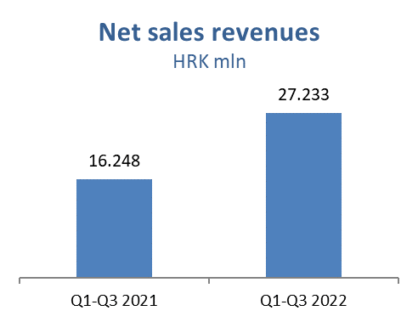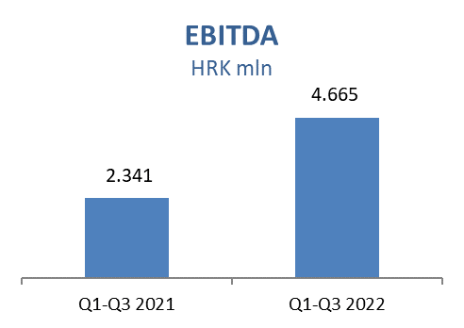
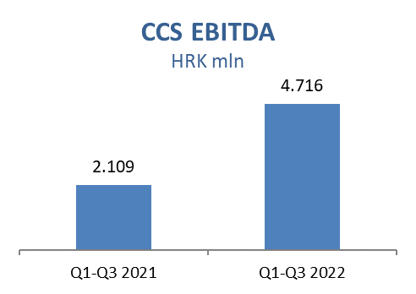
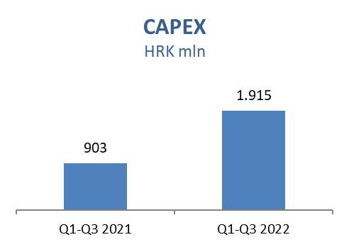

Exploration and Production
Higher prices impacted sales revenues positively by HRK 2.6 billion. Increased gas prices added HRK 1.7 billion positive effect, while 56% higher Brent price brought an additional HRK 718 million crude oil and condensate sales revenues with other products positive impact on revenues in the amount of HRK 154 million. Related to gas sales towards HEP, regulated at fixed price, negative impact is expected from Q4 2022.

Despite of successfully performed actions in the scope of Production optimization project and positive effect of putting into production two new Offshore gas wells (Ika B & Marica D), Croatian production decreased as a result of the natural decline on Onshore oil fields and higher water cut on major gas fields, and the natural decline on major gas condensate fields in Deep Podravina. In international crude oil production, Egypt performed lower at all concessions, while Angola production increased with the increase of INA share on Block 3/05 by 1.3% due to exit of the partner.

CAPEX level is higher compared to Q1-Q3 2021 mainly as a result of development activities on Croatia Offshore drilling campaign and on Croatia Onshore. Main activities in Q1-Q3 2022:
- Croatia Development Offshore:
  - Ika B-1 R well: Initial production started on March 3, 2022.
  - Marica D Dir well: Hook up completed. Trial production started on May 26, 2022. Preparation for authority technical inspection in progress.
  - Drilling and well testing of Ilena-2 finished, next to be drilled is Ida D-1 .
  - Preparatory activities for drilling of Ira-1 Dir and Ida D-2 ver in progress.
- Croatia Development Onshore:
  - EOR Šandrovac: CO₂ injection phase finished; water injection phase started in April, and it is ongoing.

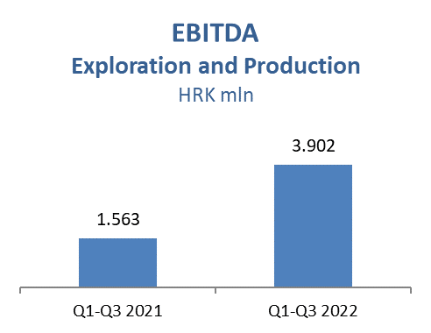
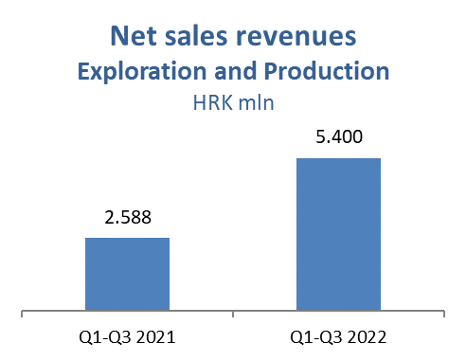

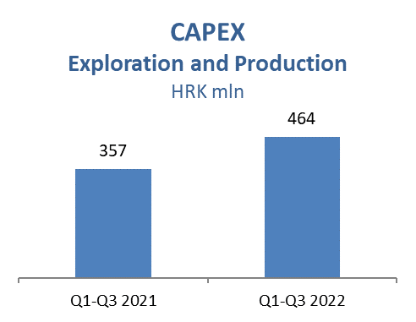

Refining and Marketing, including Consumer Services and Retail
Rijeka Refinery operations started end of March ensuring stable captive market supply in the upcoming months, mitigating risk of lower product availability on global market driven by Russia-Ukraine crisis. Favourable macro environment with strong crack spreads supported refining contribution to the financial result mostly in Q2, partially counterbalanced by high energy prices. Captive market sales was higher, with commercial margins under pressure due to government price regulations on domestic market.

Total Retail sales volumes amounted to 873 kt in Q1-Q3 2022 which is 8% above the same period of 2021, reflecting improved market conditions due to the COVID restrictions lifting and excellent tourist season and tourist consumption. Non-fuel margin increased 17% driven by expanded non-fuel offer, Fresh Corner roll-out and improved sales activities. INA Loyalty program in Croatia surpassed 400,000 registered members.

Refining and Marketing CAPEX amounted to HRK 1.3 billion:
  - Rijeka Refinery Upgrade Project - all equipment ordered and main subcontractors signed. Equipment and Long Lead Items are delivered in line with construction needs. Heavy equipment lifted on Coke Drum Structure, works on DCU continued with focus on Coke Pit and Steel Structures lifting. Coke Port connected with the land. Hydrocracker revamp, new Sulphur Recovery Unit, and pipeline connection points in focus to be ready for Refinery Shutdown in 2023. The 110kV powerline and substation in test works.
  - CDU energy efficiency upgrade project - Main design completed and submitted for obtaining Building permit.

Consumer Services and Retail capital investments amounted to HRK 66.2 million in Q1-Q3 2022 with focus on service station modernization and continued roll-out of Fresh Corner concept, which is present at 132 INA Group service stations.

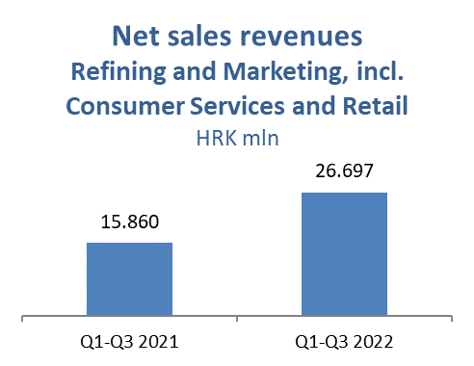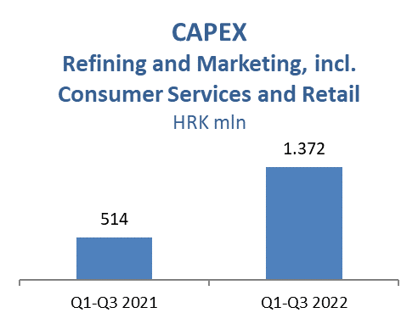
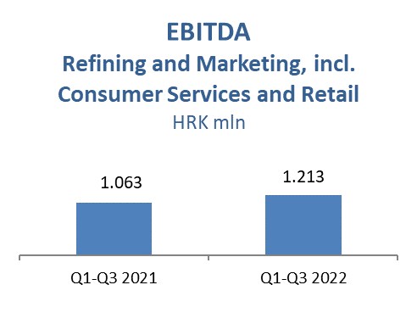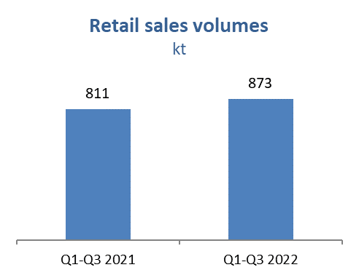

INA Group net gearing amounted to 13.1%, whilst net debt increased to HRK 1.9 billion compared to the same period last year.

