FINANCIAL RESULTS
H1 2023

Press Contact:

INA, d.d.
Corporate Communications and Marketing
Avenija Većeslava Holjevca 10, Zagreb

E-mail: pr@ina.hr
Press Centre at www.ina.hr

Despite the challenges, INA’s financial position remains robust

- In terms of external environment, the first half of 2023 was marked by stabilization of oil price, decline in gas prices and continuation of regulatory constraints, which had a negative impact on H1 2023 result.

- In line with the reduced prices, EBITDA of Exploration and Production declined by 22%, still staying rather strong with EUR 214 million in first half of 2023. Natural decline of production amounted to only 3%, which is a good result taking into consideration the portfolio maturity.

- Refining and Marketing incl. Consumer services and Retail segment result remains negatively impacted by adverse margin environment, although the sales on captive markets stayed strong.

- Investment activities resulted in EUR 218 million spending, out of which EUR 85 million is related to acquisition of 25.25% share in OMV Slovenija d.o.o., increasing INA’s share to 33%, in addition to EUR 132 million of Capital Expenditures (CAPEX). Rijeka Refinery Upgrade Project, which reached 78% completion in H1 2023, remained in the focus of CAPEX.

- Financial position remains robust with net debt almost unchanged compared to the same period last year.

Key figures:
- Net sales revenues amounted to EUR 1.7 bln
- CCS EBITDA amounted to EUR 163.6 mln
- Investments amounted to EUR 218 mln

Zagreb, 28 July 2023 – Continuation of 2023 brings stabilization of oil price and sharp decline in gas prices in H1 compared to the same period of 2022. The average realized hydrocarbon prices are reduced by 23%, which together with decreasing product price environment pushed the result down. After 2022, which was an extraordinary year for entire oil and gas industry, the first half of 2023 saw a mildening of price shocks, with INA achieving EBIDTA in the amount of EUR 183 million.
In line with the reduced prices, EBITDA of Exploration and Production declined by 22%, still staying rather strong with EUR 214 million in first half of 2023. Natural decline of production amounted to only 3%, which is a good result taking into consideration the portfolio maturity. The moderation of the expected natural decline comes mainly from offshore contribution and increased Egyptian production due to the newly drilled wells.
Refining and Marketing incl. Consumer services and Retail segment result remains negatively impacted by adverse margin environment, although the sales on captive markets stayed strong. After finalisation of brownfield part of Rijeka Refinery Upgrade Project and temporary shutdown of refining activities, Rijeka Refinery successfully started production at the end of April. Despite the continued fuel price regulation in Retail, strong growth of Retail volumes (+22% compared to H1 2022) and increase in non-fuel margin helped to partially compensate the lower result of Refining and Marketing.
Investment activities resulted in EUR 218 million spending, out of which EUR 85 million is related to acquisition of 25.25% share in OMV Slovenija d.o.o., increasing INA’s share to 33%. Continuation of the Rijeka Refinery Upgrade Project remained the focus of the CAPEX with EUR 132 million. Financial position remains robust with net debt almost unchanged compared to the same period last year.
Statement of Zsuzsanna Ortutay, President of the Management Board of INA:

“2023 continues to be an active year for INA. Intensive investment period in the Refining and Marketing segment continues, with Rijeka Refinery Upgrade Project reaching 78% completion. Following the successful finalisation of investments in the brownfield part of RRUP, an important milestone in the project, Rijeka Refinery started processing at the end of April.
Significant changes in portfolio were also made during Q2 2023. Petrokemija has been divested, while INA strengthened its share on the Slovenian market with the increase of its share in OMV Slovenija to 33%. This transaction ensured a long-term market for Rijeka Refinery products.
In Exploration and Production, natural decline is currently moderated at around 3%, while further streamlining of the portfolio was made with by completing Angola and Egypt East Yidma divestments. INA will continue with the investments in Exploration and Production with the intention of further increasing the security of energy supply for Croatia. Furthermore, it should be noted that with the normalization of the macro environment, extra profits from 2022 are not likely to repeat.
Refining and Marketing incl. Consumer Services and Retail segment operations remained cash negative due to deteriorated margin environment and fuel margin cap, which is still in force. Nevertheless, increased Retail sales volumes and constant increase in non-fuel margin positively assisted the result.”

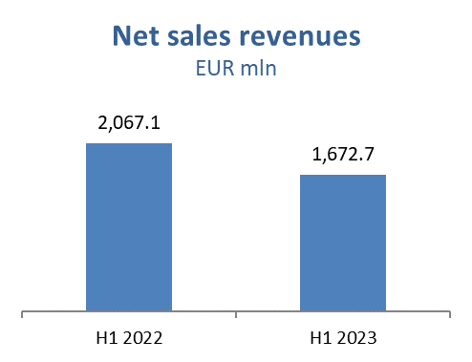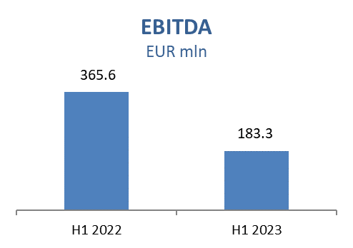
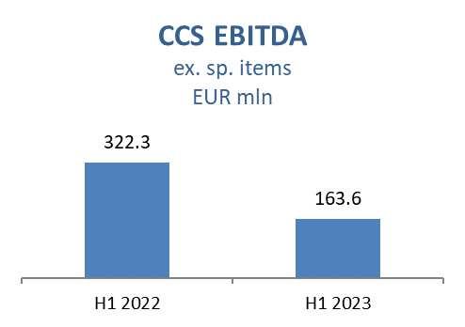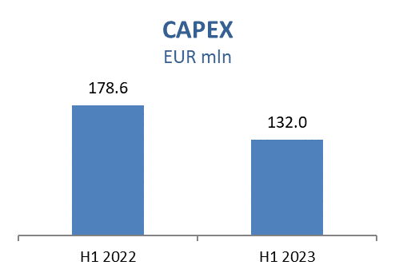

Exploration and Production
Lower prices of oil and gas impacted sales revenues negatively by EUR 87.6 million. Production decreased by 3.2%, compared to 5.6% decline in same period of 2022 vs. 2021, which is an improvement considering the maturity of INA’s oil and gas fields. However, despite Offshore contribution driven by production on Ika field after performed workover, higher production from project on Marica D well and contribution from Production System Optimization projects on Kučanci-Kapelna, Privlaka, Števkovica and Lipovljani fields, Croatian production decreased because of lower production mainly from Ferdinandovac, Vučkovec, Stružec, Đeletovci, Ivanić and Žutica fields. International production was at planned level. Production in Egypt was higher due to newly drilled wells on Sidra, Ganna and Abrar fields and performed well workovers, partially offset by the divestment of Egypt East Yidma and Angola concessions.
In the first six months of 2023 CAPEX level was lower compared to H1 2022 due to lower Croatia Offshore activities in H1 2023. Main activities were related to Croatia Exploration (Drava-03 exploration area: drilling of Veliki Rastovac-1 well finished, well test to follow), Croatia Offshore (permitting for drilling well Izabela-9 is in progress, finished abandonment activities of platform Ivana D) and Croatia Onshore (as part of production optimization 24 well workovers were performed and construction works at Gola station finished as part of Somogy gas project).

In North Bahariya 14 development wells drilled and drilling of another development well is ongoing. In Ras Qattara drilling of one development well was completed in February, and the concession extension process is ongoing.

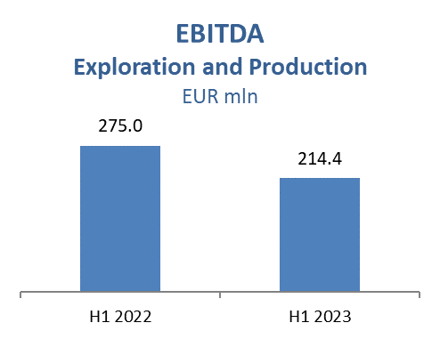
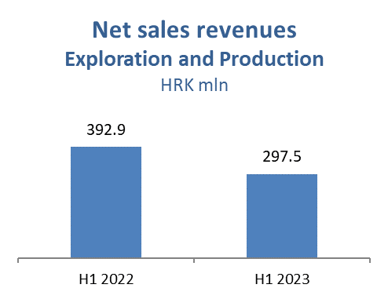

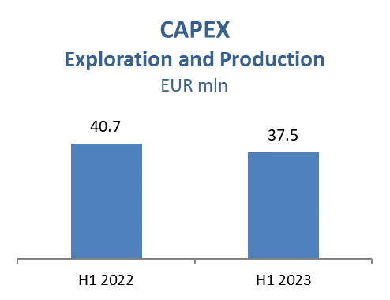

Refining and Marketing, including Consumer Services and Retail
The import of derivatives, during the planned shutdown period, due to which important works on the Rijeka Refinery Upgrade Project were completed, had a negative impact on the result, primarily due to the decreasing product price environment primarily in Q1.
After finalisation of investments in brownfield part of Rijeka Refinery Upgrade Project from January to April and temporary shutdown of refining activities, Rijeka Refinery successfully started the production end of April. Trading activities were focused on safe and timely product supply, with higher sales to Croatian market. Total Retail sales volumes amounted to 619 kt in H1 2023 which is 22% above H1 2022 due to higher realisation on Croatian market (+111 kt) mainly because of higher demand impacted also by lower fuel price compared to neighbouring countries. Non-fuel margin increased by 27% reflecting continuous expansion in consumer goods, increasing number of Fresh Corners together with the support of INA Loyalty program which surpassed 500 thousand registered members.

Refining and Marketing CAPEX amounted to EUR 84.8 million. Main project is Rijeka Refinery Upgrade Project which is at 78% completion in overall, with the engineering and procurement reaching above 99% and construction at 63%. Among other projects, the revamp works on key brownfield section were successfully completed during the refinery shutdown period, and refinery started with operation end of April. As part of Crude Destilation Unit (CDU) energy efficiency upgrade project, the first part of the works was completed during Rijeka Refinery shutdown in Q1 as planned. Also, within the project of replacement of condensing turbines with electric drives, the equipment was delivered on site as planned with construction works ongoing.
Consumer Services and Retail capital investments amounted to EUR 4.9 million in H1 2023 with focus on network modernization, resulting with total of 507 service stations in the region (out of which 390 in Croatia).

