FINANCIAL RESULTS
2023

Press Contact:

INA, d.d.
Corporate Communications and Marketing
Avenija Većeslava Holjevca 10, Zagreb

E-mail: pr@ina.hr
Press Centre at www.ina.hr

INA’s results reflect sustainable backbone for future investments

- 2023 was marked with stabilization of hydrocarbon prices, which resulted in somewhat lower but still strong results of INA Group. CCS EBITDA excl. special items amounted to EUR 496 million while net profit remained at the 2022 level with around EUR 250 million, among others due to the fact that there was no windfall tax in 2023.

- Exploration and Production EBITDA in 2023 was lower (EUR 413 million) following the external environment and moderate decline of production by 6% which was expected because of the maturity of fields and turnaround on gas treatment facilities carried out in Q3. On the other hand, contribution was achieved with the Egyptian East Damanhur concession, which started with gas production in September and commercial discovery on Veliki Rastovac-1 well.

- Refining and Marketing incl. Consumer Services and Retail segment result improved mainly due to strong market demand and positive contribution of own production. Retail sales volumes increased by 19%, mainly as a result of a good tourist season, and non-fuel margin continued to grow (+33%).

- Investment spending amounted to almost EUR 400 million, mainly focused on domestic investments and acquisition of additional 25% share in OMV Slovenia. Exploration and Production investments remained strong at EUR 100 million. Rijeka Refinery Upgrade Project reached 84% of total completion.

- Financial position was stable with net debt of EUR 216 million and 12% gearing ratio reflecting sustainable backbone for future investments.

Key figures:
- Net sales revenues amounted to almost EUR 3.9 billion
- CCS EBITDA amounted to EUR 496 million
- Investment spendings at the level of EUR 400 million

Zagreb, 16 February 2024 – Following the extraordinary 2022, 2023 was marked with stabilization of hydrocarbon prices, which resulted in somewhat lower but still strong results of INA Group. CCS EBITDA excl. special items for 2023 amounted to EUR 496 million while net profit remained at the 2022 level with around EUR 250 million, among others due to the fact that there was no windfall tax in 2023. Main driver of the EBITDA movement is the decrease of realized hydrocarbon prices by 28%, with gas prices drop much stronger than oil’s.
Exploration and Production EBITDA was lower following the external environment and moderate decline of production, EUR 413 million for 2023. Production declined in line with the expected natural decline due to maturity of fields and turnaround on gas treatment facilities. On the other hand, contribution was achieved with the Egyptian East Damanhur concession, which started with gas production in September and commercial discovery on Veliki Rastovac-1 well. All the factors resulted with only 6% lower production.
Refining and Marketing incl. Consumer Services and Retail segment result improved mainly due to strong market demand and positive contribution of own production. Retail sales volumes increased by 19%, mainly as a result of a good tourist season. Beside the strong fuel sales, non-fuel margin continued to grow (+33%). Simplified Free Cash Flow of the segment improved but stayed negative at EUR 103 million in 2023.
Investment spendings amounted to almost EUR 400 million, including EUR 85 million acquisition spending on additional 25% share in OMV Slovenia. Exploration and Production investments remained strong at EUR 100 million. Rijeka Refinery Upgrade Project reached 84% of total completion. Financial position was stable with net debt of EUR 216 million and 12% gearing ratio reflecting sustainable backbone for future investments.
Statement of Zsuzsanna Ortutay, President of the Management Board of INA:

“In 2023, amidst the aftermath of market turbulence in the previous year, the global economy found its footing, marking a period of stability. Energy prices, once erratic due to supply concerns, have now steadied, contributing to a more balanced landscape. Despite the inevitable impact of lower oil and gas prices in our Exploration and Production business, the company's overall performance remained resilient. The INA Group saw a decrease in EBITDA by 22%, which was anticipated given the prevailing environment of reduced prices. However, investments spendings reached EUR 400 million in 2023, predominantly focused on domestic investments and gaining new captive market in Slovenia by acquiring additional 25% share in OMV Slovenia. Progress on key projects like the Rijeka Refinery Upgrade Project was notable, reaching 84% completion, alongside other ongoing growth projects and efficiency enhancements across the business segments.

In Exploration and Production, essential turnaround and upgrades were executed promptly, ensuring operational continuity. The inauguration of INA's first solar plant for commercial production added a sustainable dimension to its energy portfolio, signalling a strategic shift towards renewable energy sources. The rebound of product markets was evident, with an 8% increase in total sales and a remarkable nearly 20% surge in Retail sales, attributed to heightened demand and a thriving tourist season. Amidst fluctuations in the market and operational cycles at the Rijeka Refinery, INA maintained unwavering supply reliability, underscoring its commitment to ensuring market stability.

Looking ahead to 2024, the global landscape remains fraught with challenges stemming from ongoing conflicts, casting uncertainty over markets worldwide. However, amidst these challenges lie opportunities for the energy sector's transformation. INA, fortified by its stable operations and robust financial position, stays committed to navigate the complexities ahead, embracing opportunities for further enhancement and growth.”

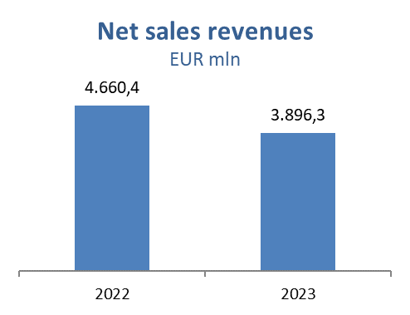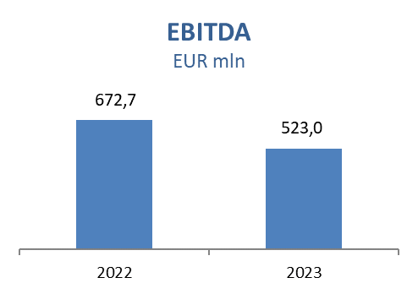
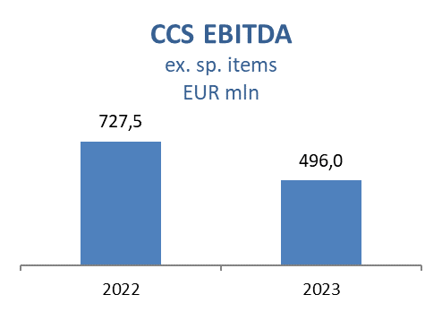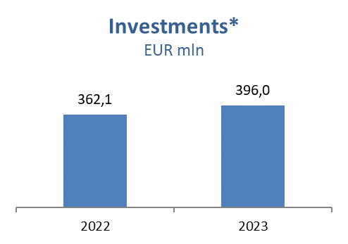
*Including acquisition of share in OMV Slovenia

Exploration and Production
Lower prices of oil and gas impacted sales revenues negatively by EUR 241.7 million. Regulatory obligation for domestically produced gas to be sold at fixed price to HEP was revoked on 7 July. Decline of production amounted to 6% which was expected due to maturity of fields and turnaround on gas treatment facilities carried out in Q3. Croatian production decreased due to lower contribution of launched projects and maintenance activities, as well as increased water cut.

International production was lower despite contribution from Egypt North Bahariya because of newly drilled wells and performed well workovers. Additionally, new gas well on East Damanhur has been put into production which represented INA's first gas production in that country since it has been operating in Egypt. A new opportunity for a step forward towards renewable energy sources has also been achieved. INA was awarded the geothermal water exploration permit for two blocks - Leščan and Međimurje 5.

In 2023 Exploration and Production CAPEX level was slightly lower compared to 2022. Main activities were related to Croatia Exploration. On Drava-03 exploration area gas discovery was confirmed with well test at Veliki Rastovac-1 well and notice of commercial discovery was submitted to the Croatian Hydrocarbon Agency.

On Croatia Offshore Ivana D platform well plug activities are completed providing safe conditions both for people and the environment. As part of production optimization projects, 58 well workovers were performed on Croatia Onshore.

In North Bahariya 22 development wells were drilled, out of which 20 producers and 2 water injectors. In Ras Qattara drilling of one development well and 14 workovers was completed, and the concession extension process is ongoing.

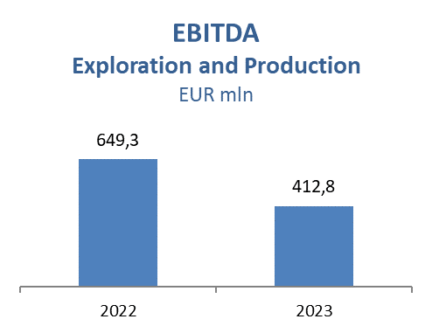
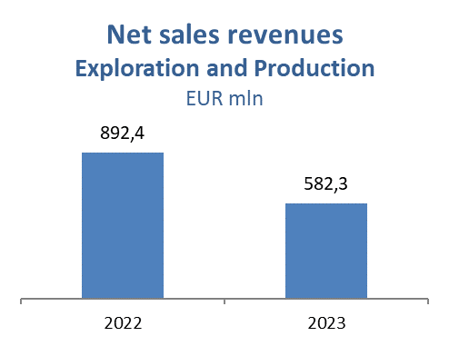

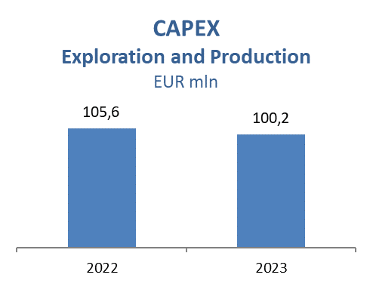

Refining and Marketing, including Consumer Services and Retail
Market backwardation during import mode of operation in H1 2023 resulted in lower product margins. Market was safely supplied via import until own refined products availability, with continuously stable market supply during strong summer season which contributed to higher captive market sales performance. After the successful start-up end of April, with positive contribution to the results, Rijeka Refinery stayed operational till beginning of December, when the planned turnaround has started.

Total Consumer Services and Retail sales volumes amounted to 1,401 kt in 2023 which was 19% above 2022 driven by higher realisation on Croatian market (+213 kt), mainly as a result of higher demand during tourist season. Non-fuel margin increased by 33% reflecting continuous expansion in consumer goods, increasing number of Fresh Corner locations and the support of INA Loyalty program which reached over 560 thousand registered members at the end of 2023 (today more than 600 thousand).

Refining and Marketing CAPEX amounted to EUR 173.2 million. Main investment is the Rijeka Refinery Upgrade Project which is at 84% completion in overall, with active works on civil and piping activities, while furnace construction is in the final stage. Connecting to the 110kV electrical network is finished and operating permits obtained. The Crude Distillation Unit (CDU) energy efficiency upgrade project is on track, with civil works in the final stage. Consumer Services and Retail capital investments amounted to EUR 18.5 million in 2023 with focus on network modernization and additional Fresh Corner implementation on 14 locations. Regional network currently consists of 506 service stations (out of which 390 in Croatia).

