FINANCIAL RESULTS
Q1 2024

Press Contact:

INA, d.d.
Corporate Communications and Marketing
Avenija Većeslava Holjevca 10, Zagreb

E-mail: pr@ina.hr
Press Centre at www.ina.hr

INA’s financial position remains stable with strong investments

- After turbulent 2022 and 2023, beginning of 2024 shows a more stable external environment on oil and gas markets. INA result in Q1 2024 was stronger primarily due to better wholesale margins and higher Retails sales. CCS EBITDA excl. special items of INA Group amounted to EUR 64 million in Q1 2024, with net profit turning positive compared to Q1 2023 and amounting to EUR 12 million.

- Exploration and Production EBITDA was lower - EUR 73 million in Q1 2024, following the lower gas price and natural decline of production.

- Refining and Marketing incl. Consumer Services and Retail segment’s result improved mainly due to the mentioned market trends and better wholesale margins. During the planned Rijeka Refinery turnaround market was supplied via imports and the overall sales increased 9%.

- Consumer Services and Retail sales volumes increased 13% compared to the Q1 2023, mainly with higher realization on domestic market and positive market trends. Non-fuel margin continued to grow with 44% margin increase.

- Overall capital expenditures amounted to EUR 101 million, roughly doubled compared to Q1 2023, with the Refining and Marketing segment contributing the most to investments. Rijeka Refinery Upgrade Project reached 87% of total completion, with other efficiency investment projects on track.

- INA’s financial position remains stable with net debt at EUR 425 million and 20% gearing ratio.

Key figures:
- Net sales revenues amounted to EUR 801.8 mln
- CCS EBITDA amounted to EUR 63.7 mln
- CAPEX amounted to EUR 101.4 mln

Zagreb, 25 April 2024 – After turbulent 2022 and 2023, beginning of 2024 shows a more stable external environment on oil and gas markets. INA result in Q1 2024 was stronger primarily due to better wholesale margins that, together with higher Retails sales, allowed for stronger overall result. CCS EBITDA excl. special items of INA Group amounted to EUR 64 million in Q1 2024, with net profit turning positive compared to Q1 2023 and amounting to EUR 12 million. These figures also show the annual seasonality where Q1 usually doesn’t contribute equally to the overall full year results compared to other quarters.
Exploration and Production EBITDA was lower following the lower gas price and expected natural decline of production, EUR 73 million in Q1 2024. Production was lower by 8% year-on-year in line with the natural production decline and water cuts on main gas fields, although the Egyptian production increased driven by gas production on East Damanhur concession.
Refining and Marketing incl. Consumer Services and Retail segment’s result improved mainly due to the mentioned market trends and better wholesale margins. During the planned Rijeka Refinery turnaround market was supplied via imports and the overall sales increased 9%. Consumer Services and Retail sales volumes increased 13% compared to the Q1 2023, mainly with higher realization on domestic market and positive market trends. Apart from the fuel sales, non-fuel margin continued to grow with 44% margin increase. Simplified Free Cash Flow of the segment was negative at EUR (68) million in Q1 2024, in line with the strong investment spending of EUR 84 million in Q1 2024.
Overall capital expenditures amounted to EUR 101 million, roughly doubled compared to Q1 2023, with the Refining and Marketing segment contributing the most to investments. In addition to investing in the mentioned turnaround, Rijeka Refinery Upgrade Project reached 87% of total completion and other efficiency investment projects in refinery were conducted. Financial position remains stable with net debt at EUR 425 million and 20% gearing ratio.

Statement of Zsuzsanna Ortutay, President of the Management Board of INA:

“Beginning of 2024, following the previous two years turmoil, shows generally good environment with the stable oil prices but the gas prices decreased significantly compared to previous period resulting in CCS EBITDA excl. special items of EUR 64 million in Q1.
Exploration and Production, combating with the expected natural decline of our portfolio, continue with new projects. On top of the new concession in Egypt, 40% of working interest in the SA-07 Croatian onshore block was acquired. Additionally, preparatory activities for INA’s first two geothermal blocks are ongoing.
Rijeka Refinery underwent the planned turnaround, during which safe and uninterrupted supply was ensured via imports. Overall Refining and Marketing sales increased in a period of favourable margins, which together with strong Retail sales turned the segments’ result positive.
Following the two solar power plants (Virje in production and Sisak in test run mode production), INA is expanding its renewable energy portfolio. Apart from preparation of additional projects for solar power plants at its locations, INA signed two contracts in sustainability area – one connected with construction of a green hydrogen plant at the Rijeka Refinery, and another one connected with a biomethane production facility in Sisak. The projects will contribute to the company’s green transition efforts, while INA will become the first producer of commercial green hydrogen in Croatia.
The funds needed for the green transformation have to be generated in INA’s core business segments, therefore it is important to keep the operations efficient and profitable. Of course, within our green transition efforts, we will also count on the co-financing from EU funds. With the usual seasonal nature of sales, the following quarters are expected to further strengthen INA’s results.”

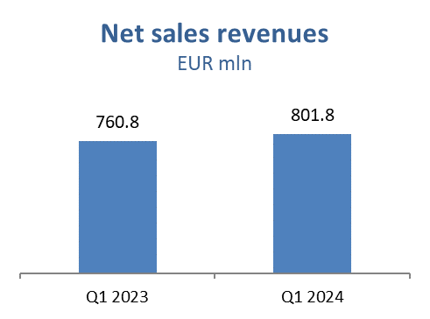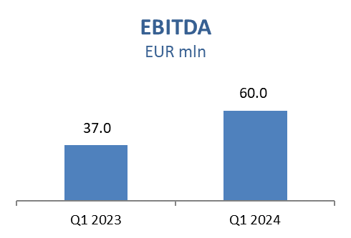
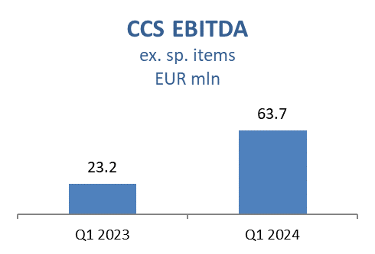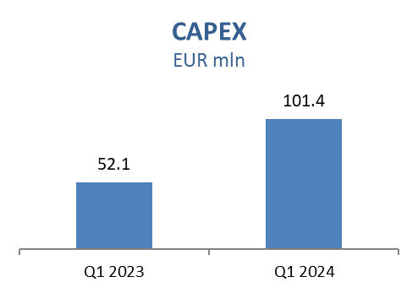

Exploration and Production
Lower prices, primarily gas prices, impacted sales revenues negatively by EUR 19.1 million. Negative effect caused by increased water cut and expected natural decline on main gas and oil fields was partially mitigated by better well performance after successfully performed well workovers on field Žutica and production optimization on several fields on onshore. International production was higher driven by gas production contribution from the new Egypt concession East Damanhur.

Segment’s CAPEX level was higher compared to Q1 2023 due to higher Croatia onshore activities. Main activities during Q1 2024 were related to acquisition of 40% of non-operated working interest in the Sava-07 Exploration Block with two wells already drilled and third ongoing. On Drava-03 there are ongoing permitting activities for two new exploration wells. Nine well workovers were performed within Production optimization program. In Egypt, two development wells were drilled on Ras Qattara production block and preparation for conducting seismic acquisition are ongoing. A significant contribution to INA’s green transition efforts is also reflected in starting 3D seismic activities in exploration area Leščan and preparatory activities for drilling geothermal wells, both in Leščan and Međimurje 5 exploration areas.

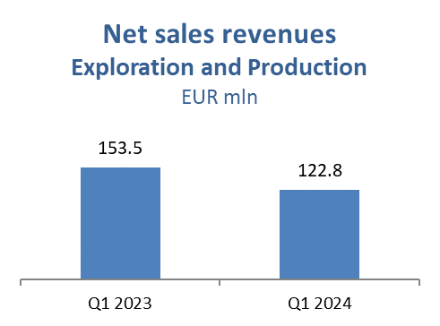
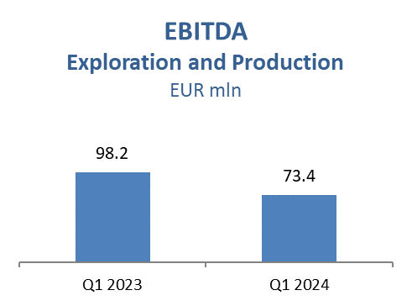

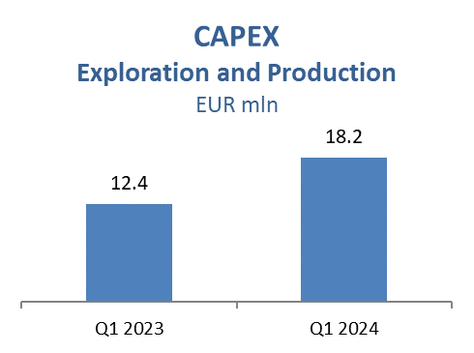

Refining and Marketing (including Consumer Services and Retail)
With turnaround activities and additional efficiency improvements and investment activities related to Rijeka Refinery Upgrade Project, refining operations were in the import mode during Q1 2024. Market was safely supplied via import until own refined products availability, with higher sales on captive market. Wholesale margins improved and gas trading performance supported improved CCS result in Q1 2024 compared to Q1 2023.

Total Consumer Services and Retail sales volumes amounted to 298 kt in Q1 2024 which is 13% above the same period last year driven by higher realisation on Croatian market (+29 kt) mainly as a result of positive market trends. Non-fuel margin increased by 44% reflecting continuous expansion in consumer goods, increasing number of Fresh Corner locations, and supported by INA Loyalty program which surpassed 620 thousand registered members.

Refining and Marketing (including Consumer Services and Retail) CAPEX amounted to EUR 83.9 million with Rijeka Refinery Upgrade Project on 87% completion in overall, and active works on civil and piping activities. Besides turnaround and modernization project, multiple projects to increase refinery efficiency have been conducted.

Consumer Services and Retail capital investments were directed in growth projects, reconstructions of existing retail sites, and additional Fresh Corner implementation. Network currently consists of 509 stations (out of which 393 in Croatia).

