FINANCIAL RESULTS
Q1 2020

Contact:
INA
Corporate Communications and Marketing
Avenija Većeslava Holjevca 10, Zagreb

Public Relations
E-mail: pr@ina.hr
Press Centre at www.ina.hr

External circumstances significantly affected the INA Group financial results

Key achievements
- Net sales revenues decreased by 7% and amounted to HRK 3,948 million
- CCS EBITDA excl. special items amounted to HRK 433 million
- CAPEX amounted to HRK 195 million
- Simplified Free Cash Flow amounted to HRK 238 million

Zagreb, April 30, 2020 – INA Group operations in Q1 2020 have witnessed unprecedented market dynamics, particularly during end of the quarter. The outbreak of the COVID-19 pandemic, coupled with the disagreement within OPEC+, have led to a parallel supply and demand shock on global oil markets which resulted with a massive drop in oil and gas prices which was reflected in the result of INA. Additionally, INA experienced a cyber-attack which created operational challenges. Nevertheless, core operations and market supply were not interrupted and the business continuity was ensured.
CCS EBITDA of INA Group remained positive in Q1 2020 at HRK 433 million, but declined by 14% compared to Q1 2019. However, the reported result turned negative, primarily due to inventory revaluation driven by the mentioned external environment. Simplified Free Cash Flow was positive at HRK 238 million emphasizing the impact of the external environment on overall result.
Exploration and Production revenues of HRK 820 million, 15% lower than same period last year, were mainly driven by 12% lower hydrocarbon prices and the natural decline in production, primarily Croatian natural gas volumes. Still, the segment EBITDA amounted to HRK 424 million.
Refining and Marketing including Consumer Services and Retail CCS EBITDA excluding special items amounted to negative HRK (15) million in Q1 2020, while the reported EBITDA, hit by the external drivers, was negative in the amount of HRK (943) million. Consumer Services sale quantities were down only by 3% in Q1, as the bigger drop in demand triggered by the COVID-19 pandemic measures occurred at the end of the reporting period. Due to pandemic restrictions that are mainly implemented in Q2, continuation of the negative trend in the coming period is expected.
CAPEX was significantly lower in Q1 2020 compared to the same period last year due to the fact that a major turnaround in the Rijeka Refinery in 2019 boosted investments last year.
Net gearing amounted to 21.4% with net debt standing at HRK 2,823 million at the end of Q1 2020.
Due to the severe macroeconomic consequences of the coronavirus pandemic, a comprehensive review of operational expenditure is carried out in order to preserve cash flow. Also, some of the planned capital spending will be adjusted until the economic lockdown caused by the emergency measures remains in place.

Statement of Mr. Sándor Fasimon, President of the Management Board of INA:
“Start of 2020 has been a challenging one for INA, starting with the cyber-attack and continuing with the outbreak of COVID-19 pandemic. It is a period for oil industry experts to be commented for years to come. Lack of consensus in OPEC+ on one side and the outbreak of COVID-19 on the other side have led to market dynamics not seen even by the most experienced O&G market professionals. Prices for crude oil have surged to levels that challenge even the strongest oil companies.
In such environment INA results are negative with EBITDA of HRK (495) million mainly due to revaluation of inventories, but stay stable when looking at pure operational level, with CCS EBITDA of HRK 433 million.
As a prelude to market drop, as mentioned, INA was also subjected to a cyber-attack during Q1 2020, but I am proud to say that during this period, despite some operational challenges, our core businesses were not endangered and we maintained stable operations and uninterrupted market supply.
Ongoing challenges such as natural production decline and overcapacity of Refining, are now even more emphasized. Despite its commitment to vertical integrated model, Exploration and Production remains main cash generator of INA and with the product prices on historically low levels and no quick recovery in sight, crisis management has become a must have for all energy companies. INA is no exemption and must quickly react to the new environment.
INA has already started implementing a number of measures, such as review of operational expenditures and adjusting some of the planned capital spending until the economic lockdown caused by the emergency measures ceases. Nevertheless, INA management stays committed to INA Downstream 2023 New course program.
Even after the emergency measures related to COVID-19 outbreak are ceased, oil & gas industry will need to make long term adjustments since the industry we knew is not likely to regain its strength in matter of months. ”

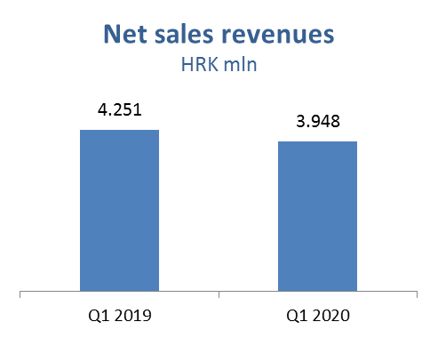

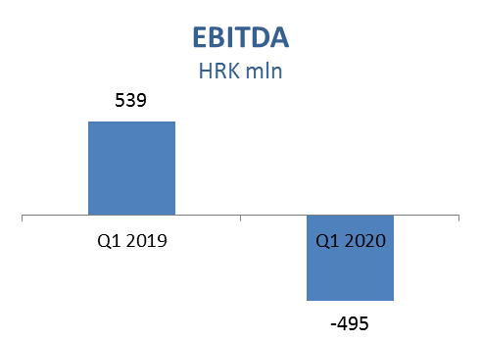

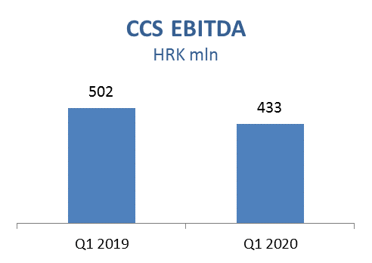

Exploration and Production – Net sale revenues in Q1 2020 decreased by 15% and amounted to HRK 820 million, while CAPEX amounted HRK 107 million, out of which HRK 73 million in Croatia.
Domestic crude oil production was lower as a result of natural decline and increased water cut mainly on Đeletovci and Stružec fields, offsetting the positive effect of EOR project on Ivanić and Žutica fields. Nevertheless, crude oil production in Egypt increased by 4% in Q1 2020, as a result of workover and drilling activities. Average hydrocarbon price decreased by 12% negatively impacting sales revenues, mainly natural gas.

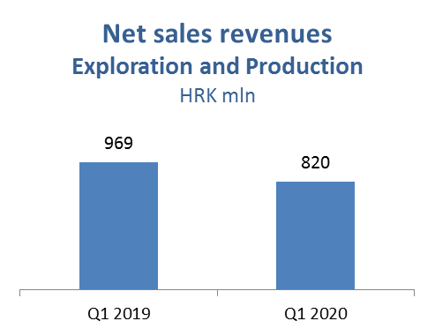

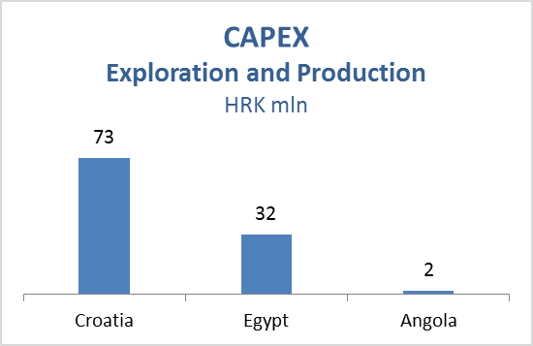

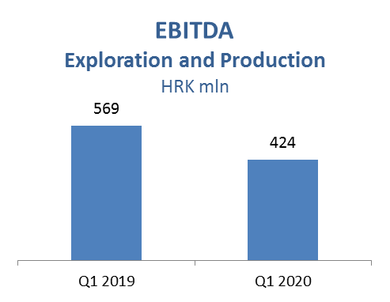

Refining and Marketing, including Consumer Services and Retail – In Q1 2020 net sales revenues decreased by 6% and amounted to HRK 3,788 million. Negative CCS EBITDA excluding special items, and consequently cash flow, reflects deteriorated external environment – primarily lower refining margin and decreased economic activity in March. The result of the segment was additionally negatively impacted by significant impairment of inventories value caused by collapsing Brent price. Processing was higher in Q1 2020 due to longer turnaround in Rijeka Refinery in Q1 2019. However, it was negatively impacted by COVID-19 related demand drop. Refined product sale increased by 15% in total and in Croatia by 5%.
Furthermore, total Retail sales volumes at 216 kt decreased 3% compared with the same period last year, affected by lower demand in the second half of March after the Covid-19 outbreak and nationwide lockdown.
Sales in Croatia increased by 5%, while non-fuel margin increased by 18%, reflecting continuous expansion in consumer goods and services.
Total CAPEX amounted to HRK 76 million; HRK 52 million in R&M, mainly driven by Residue Upgrade and Propane-Propylene Splitter projects, and HRK 24 million in Consumer Services and Retail driven by various investment projects and expanding the non-fuel offer in line with the Fresh Corner concept.
On March 31, 2020, INA Group operated a network of 508 service stations.

