FINANCIAL RESULTS
Q1-Q3 2020

Contact:
INA
Corporate Communications and Marketing
Avenija Većeslava Holjevca 10, Zagreb

Public Relations
E-mail: pr@ina.hr
Press Centre at www.ina.hr

Slowly improving external circumstances reflected on INA Group financial results

Key achievements
- Net sales revenues amounted to HRK 11,209 million
- CCS EBITDA excl. special items amounted to HRK 1,340 million
- CAPEX amounted to HRK 750 million
- Net Operating Cash Flow amounted to HRK 798 million

Zagreb, October 30, 2020 – This year, 2020, continues to be one of the most challenging years for the entire oil & gas industry and, consequently, for INA. Although the oil markets partially stabilized, the price environment is still far from pre-crisis levels. Upstream is burdened by lower realized prices, while Downstream witnesses lower demand and deteriorated refining margins.
CCS EBITDA excl. special items of INA Group amounted to HRK 1,340 million in the first nine months of 2020, of which around 40% was generated in Q3 2020 in line with the usual seasonality trends. This is 44% decline compared to the same period of 2019, still the reported EBITDA turned positive in Q3 2020 and amounted to HRK 470 million.
Operation of Exploration and Production is marked with the combination of 13% lower production due to natural decline and the decrease in realized hydrocarbon prices, driving EBITDA to HRK 707 million.
CCS EBITDA excluding special items of Refining and Marketing including Consumer Services and Retail stayed positive at HRK 536 million in Q1-Q3 2020, mainly due to the Retail contribution and additionally supported by higher share of own product sales and cost saving measures, needed to offset the effects of the economic downturn and lower demand. Retail sales volumes, although 16% lower in Q1-Q3 2020, compared to the same period in 2019, show a healthy spike in Q3 2020, with almost 300 kt of fuels sold.
Strategic projects in INA Downstream continued, amounting to almost half of the spent CAPEX. Despite the market turmoil, financial stability of INA stayed strong with a gearing ratio of 20.9%, reflecting strict cost control and efficiency improvements across all segments. At the end of Q3 2020, net debt decreased by 18% compared to the same period last year and amounted to HRK 2,503 million.

Statement of Mr. Sándor Fasimon, President of the Management Board of INA:
“During the summer months Croatia still experienced somewhat better tourist season than expected, but its effect and the seasonal increase in turnover could not compensate for the overall deteriorated environment. INA operations during 2020 required several operative adjustments in order to ensure sustainable cash generation. Postponing non-critical investments and taking other numerous internal optimization activities were the main focus, thanks to which strategic projects INA is committed to, such as Rijeka Refinery Upgrade project as part of INA R&M New Course program, are not endangered.
As for the results of the first nine months 2020, they remained strong on operational level, with CCS EBITDA of HRK 1.3 billion. Expected seasonality effect helped boost the result during Q3 2020, driving the reported EBITDA also to positive area after a negative first half 2020. Exploration and Production expected natural production decline stayed burdened by the low hydrocarbon prices, especially in the natural gas area, with reduced prices but also lower demand considering the economic downturn. Refining on one side benefited from higher share of own product sales, but on the other side witnesses’ negative margins caused by lower economic activity. Compared to first half of 2020 Retail performed significantly better in Q3 2020, and the 16% decrease in volumes compared to first nine months 2019, can be considered a strong result taking into consideration the overall market conditions.
A year such as 2020 can hardly be repeated, but the autumn and winter months are also difficult to foresee, and the full economic recovery is still not near. Still, INA will enter 2021 as a company adjusted to this unforeseen crisis and with the strong strategic projects underway, aimed to ensure future growth potential.”

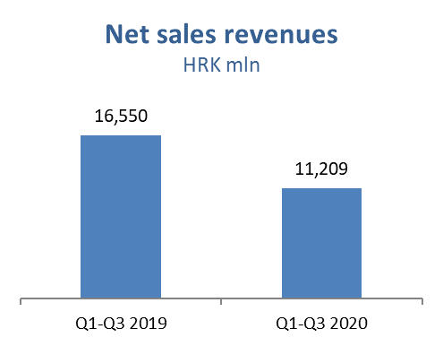

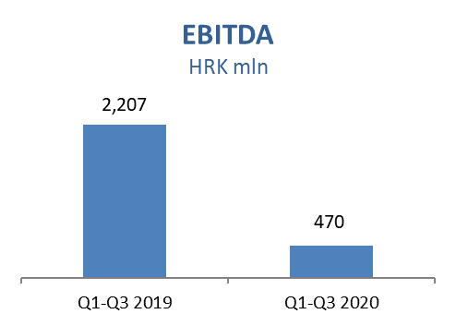

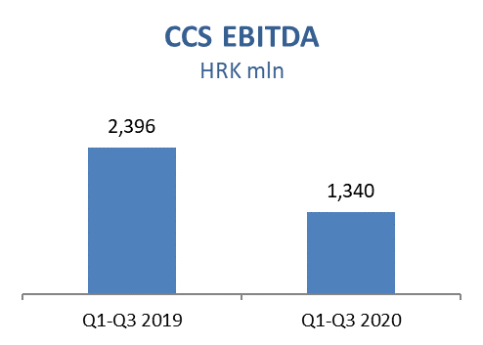

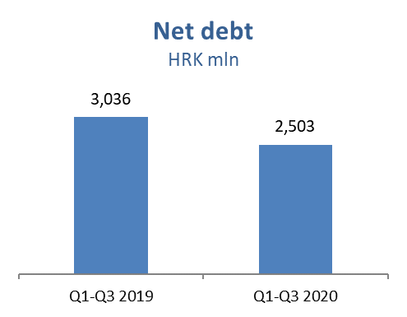

Exploration and Production – Net sale revenues in Q1-Q3 2020 decreased compared to the same period in 2019 and amounted to HRK 1,642 million, while CAPEX amounted HRK 283 million, out of which HRK 215 million in Croatia. Average hydrocarbon price decreased by 36% negatively impacting sales revenues.
Domestic crude oil production was lower as a result of natural decline and increased water cut mainly on Đeletovci and Stružec fields. However, crude oil production in Egypt increased by 2% in Q1-Q3 2020, supported by drilling activities on North Bahariya where six development wells were drilled and put in production as oil producer. INA undertakes activities aimed at mitigating negative trends – on Izabela offshore exploration area drilling of well Irena-2 was completed in October and well testing is in progress, on Drava-02 exploration area well testing of Jankovac-1 well was successfully completed and will be followed by commercial discovery decision, and on Drava-03 in mid-September seismic activities started on Crnac West polygon.

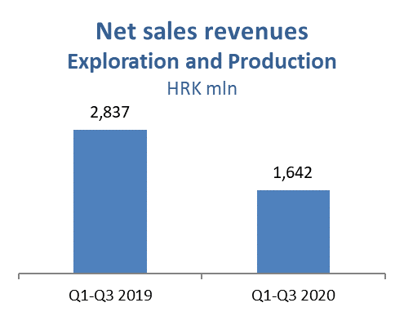

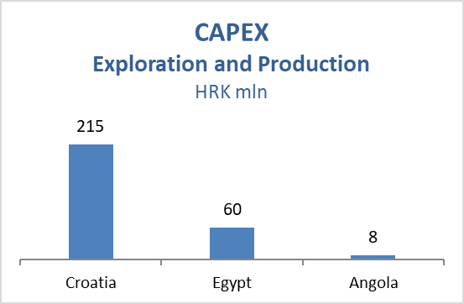

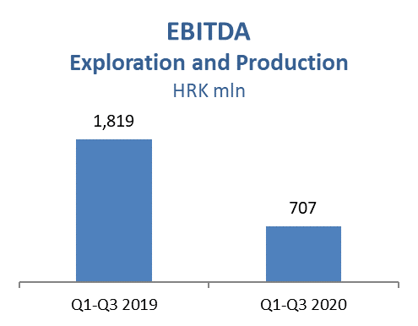

Refining and Marketing, including Consumer Services and Retail – In Q1-Q3 2020 net sales revenues amounted to HRK 10,809 million. CCS EBITDA excluding special items increased by 2% and amounted to HRK 536 million, mainly driven by higher share of own product sales, strong sales margins on core markets and disciplined cost saving measures, offsetting the lower demand for refined products caused by economic downturn. Refinery margin remained under pressure due to less favorable diesel and gasoline crack spreads, while lower crude oil prices and lower energy costs had a positive impact on the segment.
Processing was higher in the first nine months of 2020 by 296 kt due to turnaround in Rijeka Refinery in H1 2019, but still on reduced level given the decreased demand. Refined product remained flat and amounted to 3,126 kt.
Still, total Retail sales volumes at 713 kt decreased 16% compared with the same period last year due to the negative effects of the nationwide lockdowns and weaker tourist season.
Non-fuel margin increased by 2%, primarily as a result of non-fuel offer adjustment to the new market conditions.
Total CAPEX amounted to HRK 429 million; HRK 342 million in R&M, mainly driven by Residue Upgrade and Propane-Propylene Splitter projects and HRK 87 million in Consumer Services and Retail driven by various investment projects and expanding the non-fuel offer in line with the Fresh Corner concept. Also, in Q3 2020 the Biorefinery project met the formal criteria of the Ministry of Economy and Sustainable Development, which officially included it in the List of Strategic Projects, and it was assigned the head of the Operational Group who will facilitate the preparation for project implementation. Innovation Fund call application documentation preparation is in progress.
On September 30, 2020, INA Group operated a network of 507 service stations.

